West Bengal State University



Name: Aswhani Banerjee

Registration No:1342021400296

Roll:6232123

No:13299

Semester: 6

Session: 2020-2023

Signature

The Online Exam System is a comprehensive and

user-friendly platform designed to facilitate the

administration, management, and conduct of exams in a

virtual environment. This innovative project aims to replace

traditional paper-based examinations with a modern and

efficient online approach, providing a seamless experience

for students, instructors, and administrators alike.

Project tittle: Online Examination System

Project by: Aswhani Banerjee, Neha Shaw, Ankita Kairy

Name of the organization: Rishi Bankim Chandra College

Software used: Asp.net MVC .net core 6

Name of the project guide: Debasree Bhattacharyya

Date:

**_____________________________**

**Signature of the Project Guide**

**[Debasree Bhattacharyya]**

Table of Contents

1. Introduction.........................................................................................................8

 1.1. Project Overview....................................................................................8

1.2. Purpose...................................................................................................8

 1.3. Scope......................................................................................................9

 1.4. Definitions, Acronyms............................................................................9-

1.5 Functional or Specific Requirements...........................................................9-11

1.6. External Interface Requirements............................................................11

 1.7. Hardware Interfaces.................................................................................11

1.8. Software Interface....................................................................................11-12

1.9. Third Party Software Interfaces...............................................................12

 1.10. Communication Protocol..........................................................................12

1.11. Assumption and Dependency...................................................................12

1.12. Non-Functional Requirements.................................................................12

 1.13. Software System Attributes.....................................................................12

1.14. Browser Compatibility.............................................................................12-13

 1.15. Globalization Support........................................................................... 13-14

1.16. Security.....................................................................................................14

1.17. Reliability.................................................................................................14-15

1.18. Availability...............................................................................................15

1.19. Portability.................................................................................................15

 1.20. Performance.............................................................................................16

 1.21. Database Requirements..........................................................................16

1.1.1 Technologies...........................................................................................16

1.1.2 Software..................................................................................................16

 1.1.3 Hardware...............................................................................................16

1.1.4 Server.......................................................................................................17

 1.1.5 Client......................................................................................................17

 2. Analysis and Design..........................................................................................17

 2.1. Use Case Diagram...............................................................................17

2.1.1. Use case Overview.................................................................................17-18

 2.1.2. Add Faculty Use Case............................................................................19

 2.1.3. Login Use Case......................................................................................19

 2.1.4. Manage Student Groups Use Case.........................................................19

 2.1.5. Student Registration Use Case...............................................................20

 2.1.6. User Profile Edit Use Case.....................................................................20-21

2.1.7. Manage Test Use Case...........................................................................20

2.1.8. Appear for Test Use Case.......................................................................22

2.1.9. Generate Result Use Case......................................................................22

2.2. Activity Diagram..................................................................................22

2.2.1. Login Activity Diagram.........................................................................23

 2.2.2. Manage Students Activity Diagram.......................................................24

 2.2.3. Manage Tests Activity Diagram............................................................25

2.2.4. Generate Result Activity Diagram.........................................................26

2.2.5. Student Registration Activity Diagram..................................................26-27

2.2.6. Answer Test Activity Diagram..............................................................27

3. Sequence Diagrams..............................................................................28

3.1. Sequence Diagram Overview.................................................................28

 3.2. Login Sequence Diagram.......................................................................29

 3.3. Manage Student Groups Sequence Diagram..........................................29

 3.4. Student Registration Sequence Diagram................................................30

 3.5. Manage Test Sequence Diagram............................................................31

3.6. Appear for Test Sequence Diagram.......................................................32

4. Class Diagram......................................................................................32-33

5. Database Design..................................................................................34

5.1. Table: AspNetRoleClaims.....................................................................34

 5.2. Table: Choice....................................................................34

 5.3. Table: Questions..............................................................................35

 5.4. Table: Answer.........................................................................35

 5.5. Table: Subjects..................................................................................35

5.6. Table: Students........................................................................................35

5.7. Table: Standards.......................................................................................36

5.8. Table: AspNetRoles.....................................................................36

5.9.Table: AspNetUserClaims………………………………………………………….36

5.10.Table: AspNetUserLogins……………………………………………………………..36

5.11.Table: AspNetUserRoles………………………………………………………………37

**5**.12.Table: AspNetUsers…………………………………………………………………37-38

5.13.Table: AspNetUserTokens……………………………………………………………………..38

5.14.Table: Categories…………………………………………………………………………..38

5.15.Table: Companies…………………………………………………………………38

5.16.Table: CoverTypes………………………………………………………..39

5.17.Table: Departments…………………………………………………………………39

5.18Table: ExamMarks………………………………………………………………39

5.19.Table: Studentsubject………………………………………………………..39-40

6. User Interfaces...................................................................................................40

 6.1. Home Page...........................................................................................40

6.2. About Us.........................................................................................41

6.3. Login Interface.....................................................................................41

6.4. Admin Login Interface ……………………………………………………………….41-42

6.4.1.Admin Home Page…………………………………………………………………………………..42

6.4.2.Question List…………………………………………………………………………………………..43

6.4.3.Create Question………………………………………………………………………………….43

6.4.4.Update Question……………………………………………………………………………….43-45

6.4.5.Delete Question ………………………………………………………………………44-45

6.4.6 .Choice List……………………………………………………………………………..46-48

6.4.7. Create Choice……………………………………………………………………………48

6.4.8.Update Choice………………………………………………………………………………….48-49

6.4.9.Delete Choice……………………………………………………………………………………49

6.4.10.Answer List………………………………………………………………………………50

6.4.11.Create Answer……………………………………………………………………….50-52

Update Answer

Delete Answer

6.4.12.Student Subject List…………………………………………………………………52

6.4.13.Selecting Individual Student for Examination……………………………….53

6.4.14.Update Student Subject…………………………………………………………….53

6.4.15.Delete Student Subject……………………………………………………………….53-54

6.4.16.Registration in Admin Portal……………………………………………………………54

6.4.17.Subject List……………………………………………………………………………………..55

6.4.18.Create Subject………………………………………………………………………………55

6.4.19.Update Subject…………………………………………………………………………56

6.4.20.Delete Subject…………………………………………………………………………….56-57

6.4.21.Class List……………………………………………………………………….57

6.4.22.Create Class…………………………………………………………………………….57-58

6.4.23.Edit Class………………………………………………………………………………………58

6.4.24.Delete Class………………………………………………………………………………58-59

6.4.25.Student List…………………………………………………………………………………………….60

6.4.26.Create Student…………………………………………………………………………………………60

6.4.27.Update Student……………………………………………………………………………..60-61

6.4.28.Delete Student…………………………………………………………………………..61

6.4.29.Create Student Examination Portal………………………………………………62

6.4.30.Student Login interface……………………………………………………………….62-63

6.4.31.Student Home Page………………………………………………………………….63

6.4.32.Student Examination Login interface………………………………………….64

6.4.33.Student Examination List………………………………………………………………65

6.4.34.Attemping Exam………………………………………………………………………66-67

6.4.35.Student Performance………………………………………………..67-68

7.Testing………………………………………………………………………69-71

8.Source Code………………………………………………………………71-73

9.Scope for Enhancement …………………………………………………………………………….73

References

Introduction

* 1. Project Overview

This project assesses students by conducting online objective weekly tests. The tests would be highly customizable. This project will enable educational institutes to conduct test and have automated checking of answers based on the response by the candidates.

 The project allows Admin to create their own tests. It would enable educational institutes to perform tests, quiz and create feedback forms. It asks Admin to create his/her set of questions. Admin then creates  and adds related students . Further the tests are associated with specific groups so that only associated students can appear for the test. The result of the response would be available to the student of the question set. This project would be helpful for creating practice tests, say for educational institutes and as a feedback form.

1.2.Purpose:

• Responses by the candidates will be checked automatically and instantly.

 • Online examination will reduce the hectic job of assessing the answers given by the candidates.

 • Being an integrated Online Examination System it will reduce paper work.

• Can generate various reports almost instantly when and where required.

 1.3. Scope This project would be very useful for educational institutes where regular evaluation of students’ is required. Further it can also be useful for anyone who requires feedback based on objective type responses.

1.4.Definitions,

Acronyms

The sub-section provides the definitions of all terms, acro.nyms, and abbreviations used in this document to understand the SRS properly.

|  |  |  |
| --- | --- | --- |
| Sr.  No. | Terms/Acronyms | Description |
| 1. | Administrator | Super user, adds faculty and manages system. posts set of questions, the available options and correct answers. |
| 2. | Student | User mostly a student who will appear for the examination |
| 3. | Individual | Can only login |

**1.5. Functional or Specific Requirements**

Required software is for conducting on-line `objective’ type examination and providing immediate results. The system should satisfy the following requirements:

**• Administrator Aspect**

 1. Taking backup of the database

2. Editing/Deleting/Creating the database.

 3. Adding or removing user.

 4. Changing the password.

5. Accepting registrations of candidates

 6. Adding the candidate to a test

7. Create/Edit/Delete candidate

8. Creating a test

 9. Posting questions in the above test

10. Posting multiple options to respective question

11. Marking correct answer within the given options

12. Specifying to allow user defined answer

 13. Time limit of each question is one minute.

 14. Whether to randomize the questions

15. Whether to randomize the options displayed

 16. To allow the test to be taken in practice mode where the correct answer is shown immediately after the candidate complete the examination.

17. No negative marks for wrong responses for online examination.

**• Student Aspect:**

 1. Requesting registration

1. Logging into the system.

1. Logging into the exam portal.

 4. Selecting the Subject.

5. Appearing for the examination.

 6. After the examination is over then the student can check their immediate result.

7. Reviewing the given responses.

8. Changing password.

9. Resetting of forgotten password

* **Individuals**

1. Logging into the system.

**• Analysis**

1. Authenticating users based on username and password

2. Keeping session track of user activity

 3. Recording candidates’ responses to every question

 4. Checking whether the given response is correct or not

5. Keeping recent test performance of the students.

**1.6.External Interface Requirements**

**1.7.Hardware Interfaces**

 Server side hardware

 • Hardware recommended by all the software needed.

• Communication hardware to serve client requests

Client side hardware

• Hardware recommended by respective client’s operating system and web browser.

• Communication hardware to communicate the server.

**1.8.Software Interface**

Server-side software

 • Web server software, IIS

 • Server side scripting tools: ASP MVC .NET CORE

• Database tools: Microsoft SQL Server

 • Compatible operating system: Window

• Web browser supporting JavaScript, refer Browser Compatibility

**1.9.Third Party Software Interfaces**

 Entity Framework

**1.10.Communication Protocol**

Following protocols are required to be permitted on the server side

• HTTP incoming request

• HTTPS incoming request if secure gateway is implemented Following protocols are required to be permitted on the client side

 • HTTP outgoing request

 • HTTPS outgoing request if secure gateway is implemented

**1.11.Assumption and Dependency**

 1. Username are valid email addresses of respective user

 2. Administrator has the authority to add/delete users.

 3. Faculty have the authority to approve/expel student

4. Faculty have the authority to change student’s group

**1.12.Non-Functional Requirements**

 • System should be able handle multiple users

• Database updating should follow transaction processing to avoid data inconsistency.

**1.13.Software System Attributes**

**1.14.Browser Compatibility**

The project being web based required compatibility with at least the popular web browsers. Microsoft Windows XP and above, Linux and Macintosh being the current popular operating system and Microsoft Internet Explorer, Mozilla Firefox, Opera, Safari and Google Chrome being the currently popular web browsers.

|  |  |  |  |  |  |  |  |
| --- | --- | --- | --- | --- | --- | --- | --- |
| Operating System  Browsers | Win 2000 | WinXP | WinXPSP2 | Win Vista | Win 7 | Mac OS | Linux |
|  | Modern | Browsers |  |  |  |  |  |
| IE 8.0 | N/A | SUPP | SUPP | SUPP | SUPP | N/A | N/A |
| IE 7.0 | N/A | N/A | N/A | N/A |  | N/A |  |
| IE 6.0 | N/A | N/A | N/A | N/A |  | N/A |  |
| Firefox 3.5 | N/A | SUPP | N/A | N/A |  | N/A |  |
| Opera 9.23 | N/A | SUPP | N/A | N/A |  | N/A |  |
| Safari 9.27 | N/A | SUPP | N/A | N/A |  | SUPP |  |
|  | “Legacy” | Old | Browsers |  |  |  |  |
| IE 5.5 | N/A | N/A | N/A | N/A |  | N/A |  |
| Netscape | N/A | N/A | N/A | N/A |  | N/A |  |

**1.15.Globalization Support**

 The questionnaires and their respective options provided by the admin must be in English.

**List of Locale**

 The system will be in US English.

|  |  |  |  |  |  |
| --- | --- | --- | --- | --- | --- |
| Locale | Date Format | Time Format | Currency Format | Calendar | Character Set |
| En-US | Use Default | Use Default | Use Default | Use Default | SBCS |

**Content to be localized**

 The following table lists all the possible area in the system and also mentions whether that area should support Globalization.

|  |  |
| --- | --- |
| Interface Type | Needs Localization? |
| User Interface | Yes* |
| Email sent by system, | Yes* |
| Standard Error and exceptions logged by system in error log | No |
| Logos, Images | No |
| Unit of Measurement (Ex. Length, Weight, Area, Volume, Paper Size ete) | No |
| Report | Yes* |

*Limited to questionnaires set by user who posted questions.

**1.16.Security**

 • Administrator has the highest authority to edit/delete/create database, and also have the authority to add/expel students

• Students can only view their test records.

• Administrator can view all the test records of every student.

 • Critical information like passwords should be transferred in encrypted form with Identity framework of Microsoft.

 • Passwords should be stored in encrypted form

• Password will not be mailed to the user in case user forgets password, instead either temporary password or a password reset link will be sent.

**1.17.Reliability**

Data validation and verification needs to be done at every stage of activity.

• Validating user input

• Use of locking mechanism while updating database like transaction processing

• Recovering the transaction using rollback.

**1.18.Availability**

The examination system being an online system should be available anytime.

Constraints:

Though the system should be available 24x7 some features may be restricted.

 • Quiz creator may allow the specific test to be available only at certain time like scheduled examination.

 • The test may be time limited so the candidates appearing will have limited time to answer the test.

**1.19.Portability**

• The web application will be built using Asp MVC .Net Core which has support to run on any platform provided the required compilers are available.

• For database either XML or MySQL would be used, that too has extensive support over many popular architectures and operating systems.

 Constraints:

Portability would be limited to the support provided by the respective application vendor on various architectures and operating environments.

**1.20.Performance**

 The system would be used by multiple users at a time and may grow as time passes; the system would need to implement multithreading to achieve acceptable performance. Further a database connection pool may also be required for assigning faster database connection.

**1.21.Database Requirements**

 Database fields for questions and respective options must be in Varchar to handle English characters

**1.1.1.Technologies**

This section lists all the technologies for the web based system.

 • Asp MVC .Net Core scripting for server side scripting as it has a very strong support for XML and MySQL.

• IIS as web server has a tight integration with Asp MVC .Net Core and is also available for various popular platforms.

**1.1.2.Software**

Visual Studio Community Edition 2022 developing tools.

IIS as Web server

**1.1.3Hardware**

The recommended hardware specified by the respective software would suffice the needs. The memory and processing power needed would increase as the number of users increase. The estimated hardware requirements are as specified.

**1.1.4.Server**

The minimum hardware as recommended by all of the software required on server side say web server, operating system and development software

• Processing speed of 1.6 GHz

1 GB of RAM

• Network interface

**1.1.5.Client**

 The minimum hardware as recommended by all of the software required on client side say web browser, operating system

 • Minimum hardware depending on the operating system used

• True color visual display unit

• User peripherals for better interaction

2. Analysis and Design

2.1. Use Case Diagram

2.1.1. Use case Overview

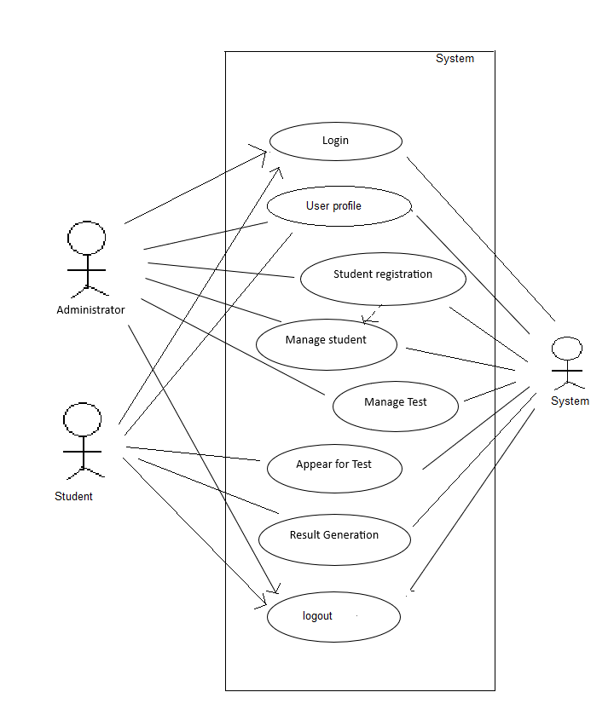

2.1.2.Add Student Exam Login Use Case

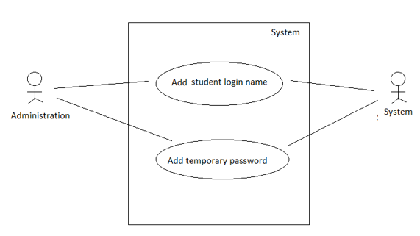

2.1.3.Login Use Case

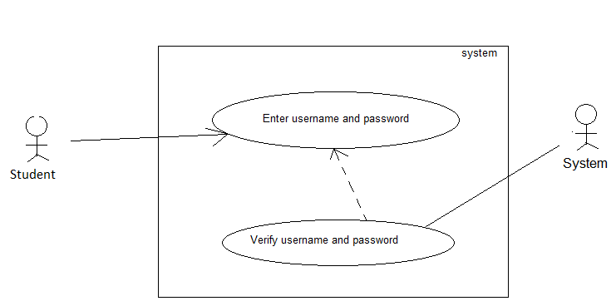

2.1.4.Student Registration Use Case

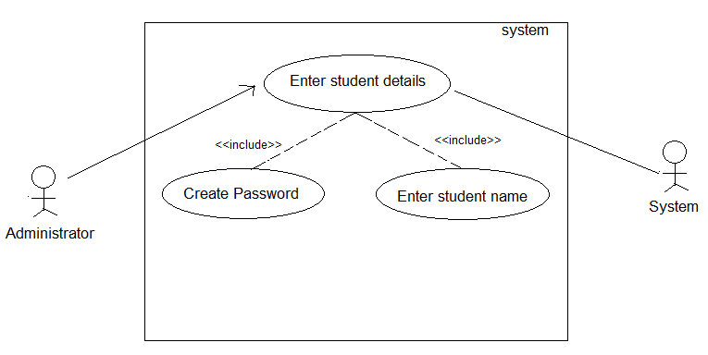

2.1.5.User Profile Edit Use Case

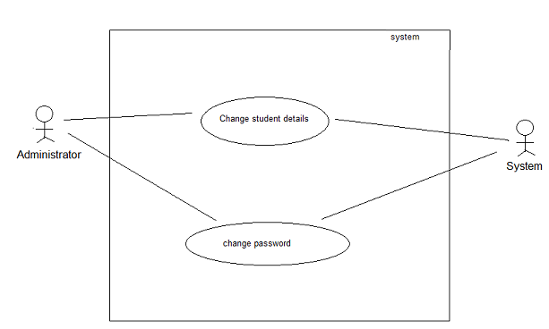

2.1.6.Manage Test Use Case

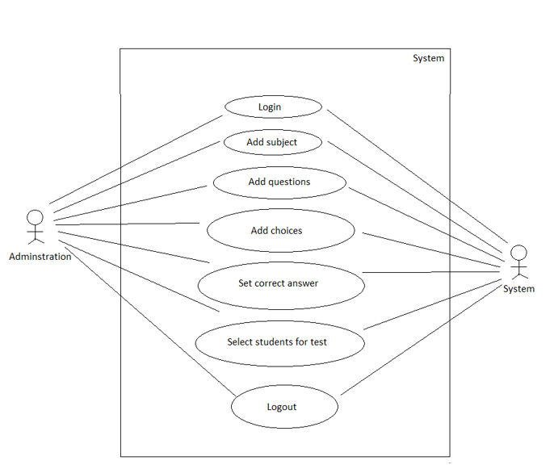

2.1.7.Appear for Test Use Case

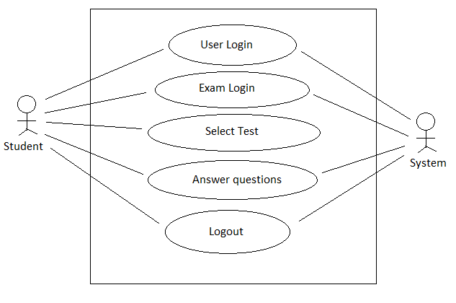

2.1.8.Generate Result Use Case

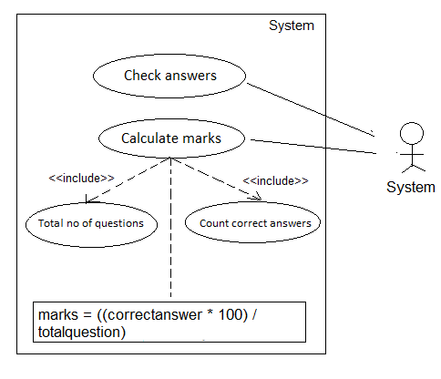

2.2.Activity Diagram

2.2.1.Login Activity Diagram

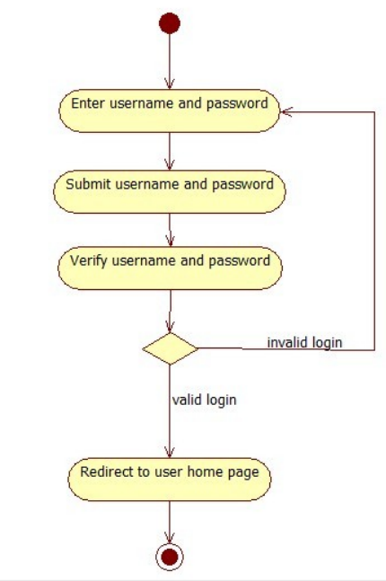

2.2.2. Manage Students Activity Diagram

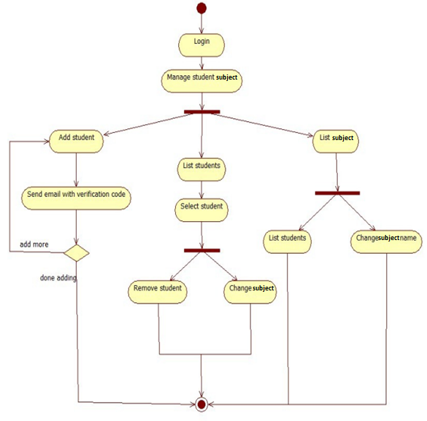

2.2.3. Manage Tests Activity Diagram

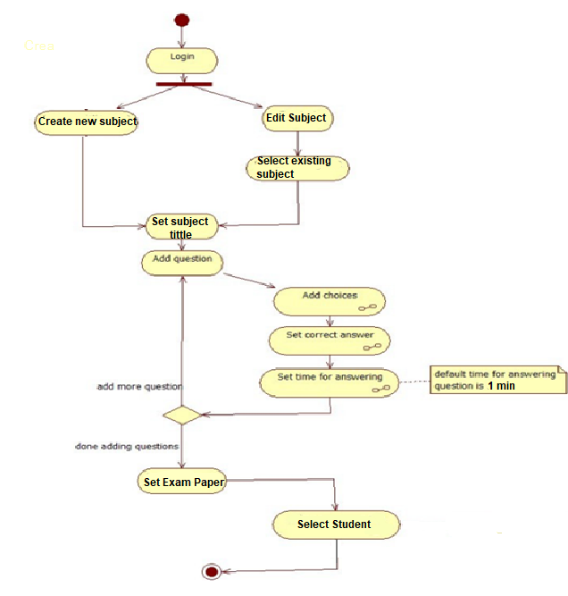

##### ***2.2.4.Generate Result Activity Diagram***

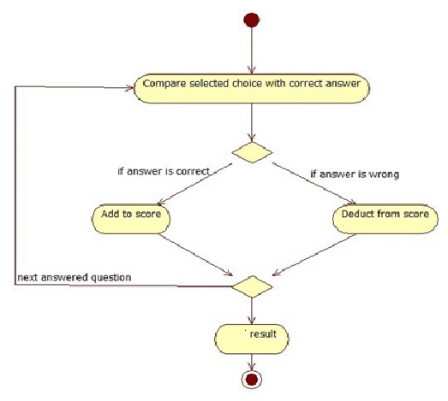

#### **2.2.5.Answer Test Activity Diagram**

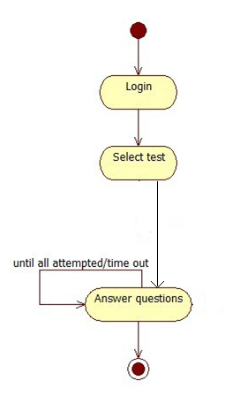

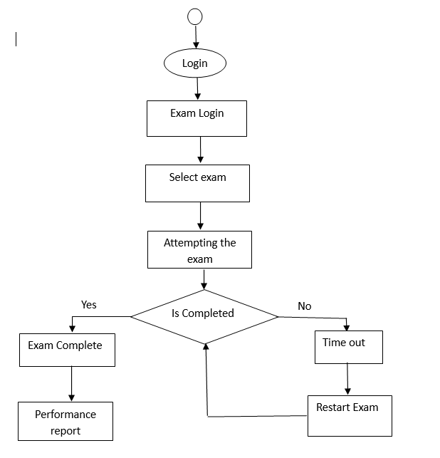

### **3.Sequence Diagrams**

**3.1.Sequence Diagram Overview**

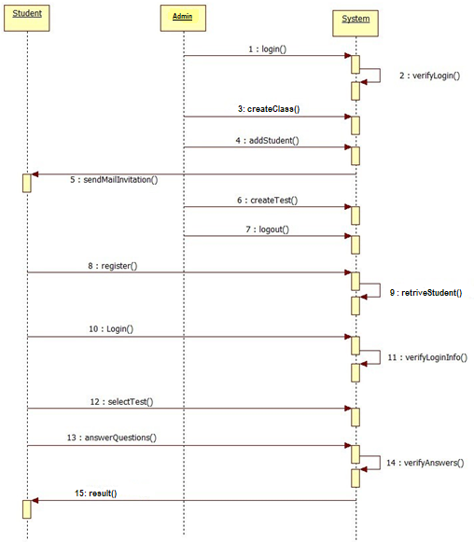

#### **3.2.Login Sequence Diagram**

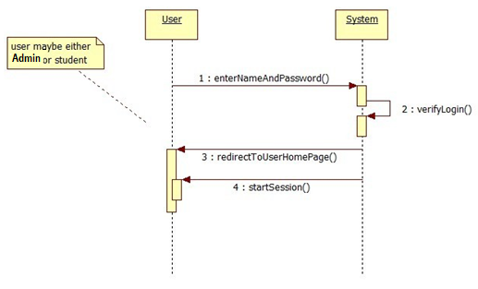

#### **3.3.Manage Student Sequence Diagram**

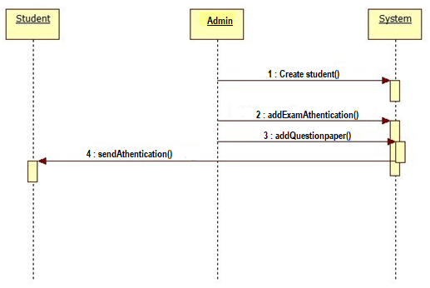

#### **3.4.Student Registration Sequence Diagram**

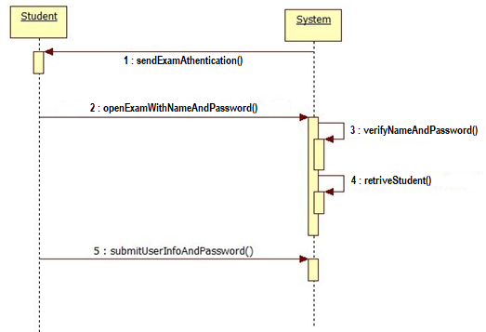

#### **3.5.Manage Test Sequence Diagram**

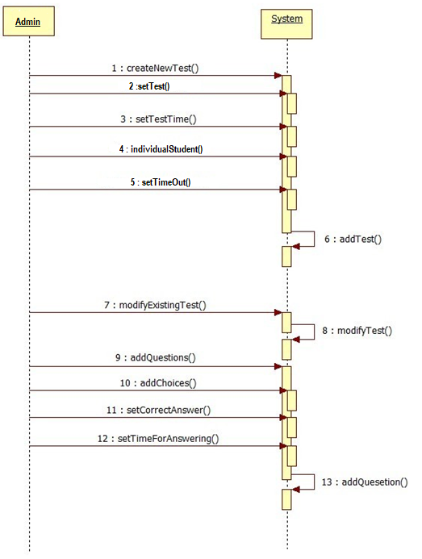

#### **3.6.Appear for Test Sequence Diagram**

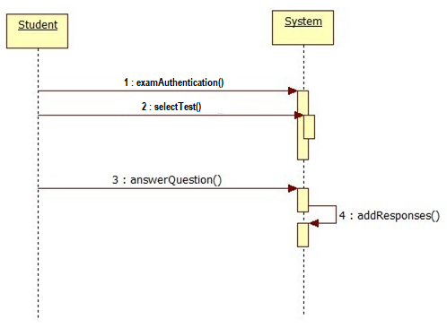

### **.4.Class Diagram**

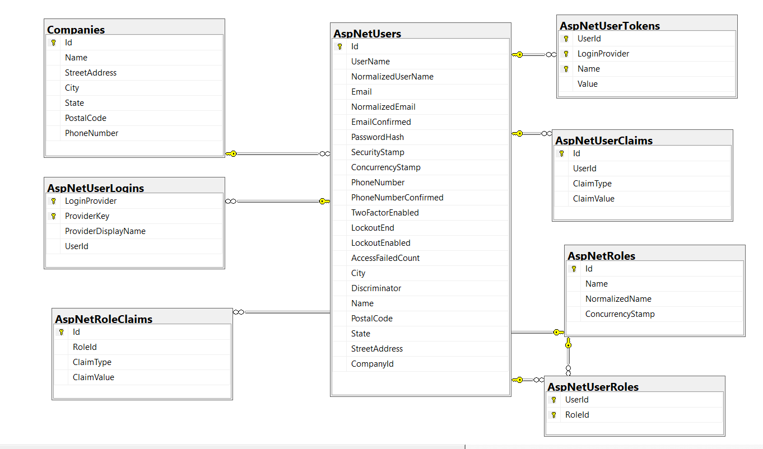

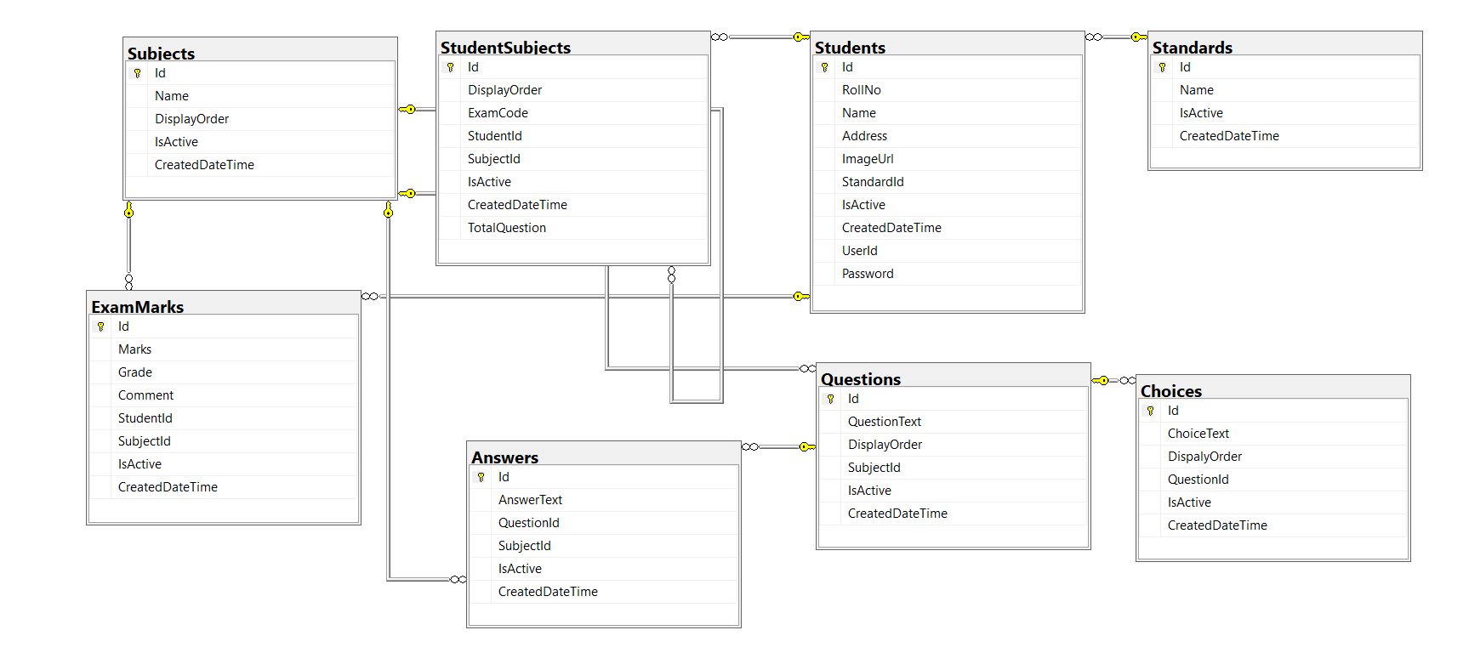

**5.Database Design**

**5.1Table:** **AspNetRoleClaims**

|  |  |  |
| --- | --- | --- |
| **Field Name** | **Data Type** | **Constraints/Description** |
| ID | Integer | Primary Key, AutoIncrement |
| RoleId | nvarchar2 | Foreign Key |
| ClaimType | nvarchar2 |  |
| ClaimValue | nvarchar2 |  |

**5.2.Table: Choice**

|  |  |  |
| --- | --- | --- |
| **Field Name** | **Data Type** | **Description** |
| ID | Unsigned Integer | Primary Key, AutoIncrement |
| ChoiceText | nVarchar |  |
| DispalyOrder | nvarchar |  |
| QuestionId | Integer | Foreign key |
| IsActive | IsActive |  |
| CreatedDateTime | datetime2 |  |

**5.3.Table: Questions**

|  |  |  |
| --- | --- | --- |
| **Field Name** | **Data Type** | **Description** |
| ID | Integer | Primary Key, AutoIncrement |
| QuestionText | nvarchar |  |
| DisplayOrder | integer |  |
| SubjectId | inreger | Foreign key |
| IsActive | bit |  |
| CreatedDateTime | datetime2 |  |

**5.4.Table: Answer**

|  |  |  |
| --- | --- | --- |
| **Field Name** | **Data Type** | **Description** |
| ID | Integer | Primary Key, AutoIncrement |
| AnswerText | nvarchar |  |
| QuestionId | Integer | Foreign key |
| SubjectId | Integer | Foreign key |
| IsActive | bit |  |
| CreatedDateTime | datetime2 |  |
|  |  |  |

**5.5.Table: Subjects**

|  |  |  |
| --- | --- | --- |
| **Field Name** | **Data Type** | **Description** |
| ID | Integer | Primary Key, AutoIncrement |
| Name | nvarchar |  |
| DisplayOrder | Integer |  |
| IsActive | bit |  |
| CreatedDateTime | datetime2 |  |

**5.6.Table: Students**

|  |  |  |
| --- | --- | --- |
| **Field Name** | **Data Type** | **Description** |
| ID | Integer | Primary Key, AutoIncrement |
| RollNo | nvarchar |  |
| Name | nvarchar |  |
| Address | nvarchar |  |
| ImageUrl | nvarchar |  |
| StandardId | integer | Foreign key |
| IsActive | bit |  |
| CreatedDateTime | datetime2 |  |
| UserId | nvarchar |  |
| Password | nvarchar |  |
|  |  |  |

**5.7.Table: Standards**

|  |  |  |
| --- | --- | --- |
| **Field Name** | **Data Type** | **Description** |
| ID | Integer | Primary Key, AutoIncrement |
| Name | nvarchar2 |  |
| IsActive | bit |  |
| CreatedDateTime | datetime2 |  |

2

**5.8.Table: AspNetRoles**

|  |  |  |
| --- | --- | --- |
| **Field Name** | **Data Type** | **Description** |
| ID | nvarchar | Primary Key, AutoIncrement |
| Name | nvarchar | Foreign |
| NormalizedName | nvarchar | Foreign |
| ConcurrencyStamp | nvarchar |  |

**5.9.Table: AspNetUserClaims**

|  |  |  |
| --- | --- | --- |
| **Field** **Name** | **Data Type** | **Decription** |
| Id | integer | Primary Key, AutoIncrement |
| UserId | nvarchar | Foreign key |
| ClaimType | nvarchar |  |
| ClaimValue | nvarchar |  |

## **5.10.Table: AspNetUserLogins**

|  |  |  |
| --- | --- | --- |
| Field Name | Data Type | Decription |
| LoginProvider | nvarchar | Primary Key, AutoIncrement |
| ProviderKey | nvarchar |  |
| ProviderDisplayName | nvarchar |  |
| UserId | nvarchar | Foreign key |

**5.11.Table: AspNetUserRoles**

|  |  |  |
| --- | --- | --- |
| Field Name | Data Type | Decription |
| UserId | nvarchar | Primary Key, AutoIncreme,Foreign key |
| RoleId | nvarchar | Primary Key, AutoIncreme,Foreign key |

**5.12.Table: AspNetUsers**

|  |  |  |
| --- | --- | --- |
| **Field Name** | **Data Type** | **Decription** |
| Id | nvarchar |  |
| Username | nvarchar | Primary Key, AutoIncrement |
| NormalizedUserName | nvarchar |  |
| Email | nvarchar |  |
| NormalizedEmail | nvarchar |  |
| EmailConfirmed | bit |  |
| PasswordHash | nvarchar |  |
| SecurityStamp | nvarchar |  |
| ConcurrencyStamp | nvarchar |  |
| PhoneNumber | nvarchar |  |
| PhoneNumberConfirmed | bit |  |
| TwoFactorEnabled | bit |  |
|  |  |  |
| LockoutEnd | datetimeoffset |  |
| LockoutEnabled | bit |  |
| AccessFailedCount | integer |  |
| City | nvarchar |  |
| Discriminator | nvarchar |  |
| Name | nvarchar |  |
| PostalCode | nvarchar |  |
| State | nvarchar |  |
| StreetAddress | nvarchar |  |
| CompanyId | integer | Foreign key |

## **5.13.Table: AspNetUserTokens**

|  |  |  |
| --- | --- | --- |
| **Field Name** | **Data Type** | **Decription** |
| UserId | nvarchar | Primary Key, AutoIncrement,Foreign key |
| LoginProvider | nvarchar | Primary Key, AutoIncrement |
| Name | nvarchar | Primary Key, AutoIncrement |
| Value | nvarchar |  |

5.14.Table: **Categories**

|  |  |  |
| --- | --- | --- |
| **Field Name** | **Data Type** | **Decription** |
| Id | integer | Primary Key, AutoIncrement |
| Name | nvarchar |  |
| DisplayOrder | integer |  |
| CreatedDateTime | datetime2 |  |

**5.15.Table: Companies**

|  |  |  |
| --- | --- | --- |
| **Field Name** | **Data Type** | **Decription** |
| Id | Integer | Primary Key, AutoIncrement |
| Name | nvarchar |  |
| StreetAddress | nvarchar |  |
| City | nvarchar |  |
| State | nvarchar |  |
| PostalCode | nvarchar |  |
| PhoneNumber | nvarchar |  |

5.16.Table: CoverTypes

|  |  |  |
| --- | --- | --- |
| **Field Name** | **Data Type** | **Decription** |
| Id | Integer | Primary Key, AutoIncrement |
| Name | nvarchar |  |

**5.17.Table: Departments**

|  |  |  |
| --- | --- | --- |
| **Field Name** | **Data Type** | **Decription** |
| Id | Integer | Primary Key, AutoIncrement |
| Name | nvarchar |  |
| PhoneNumber | nvarchar |  |
| IsActive | bit |  |
| CreatedDateTime | datetime2 |  |

**5.18Table: ExamMarks**

|  |  |  |
| --- | --- | --- |
| **Field Name** | **Data Type** | **Decription** |
| Id | Integer | Primary Key, AutoIncrement |
| Marks | float |  |
| Grade | nvarchar |  |
| Comment | nvarchar |  |
| SubjectId | Integer | Foreign key |
| StudentId | Integer | Foreign key |
| IsActive | bit |  |
| CreatedDateTime | datetime2 |  |

5.19.Table: **Studentsubject**

|  |  |  |
| --- | --- | --- |
| **Field Name** | **Data Type** | **Decription** |
| Id | Integer | Primary Key, AutoIncrement |
| DisplayOrder | Integer |  |
| ExamCode | nvarchar |  |
| StudentId | Integer | Foreign key |
| SubjectId | Integer | Foreign key |
| IsActive | bit |  |
| CreatedDateTime | datetime2 |  |
| TotalQuestion | Integer |  |

## **6. User Interfaces**

The interfaces of this system are as below

### **6.1. Home Page**

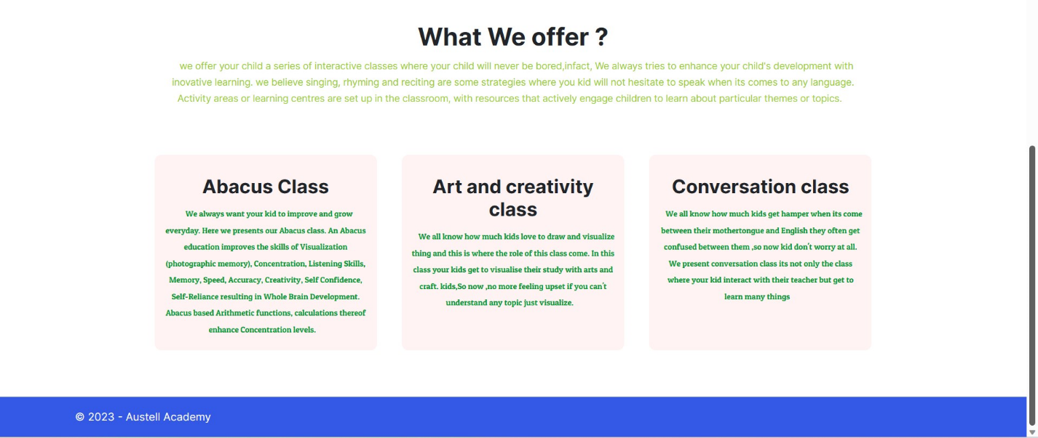

### **6.2About Us**

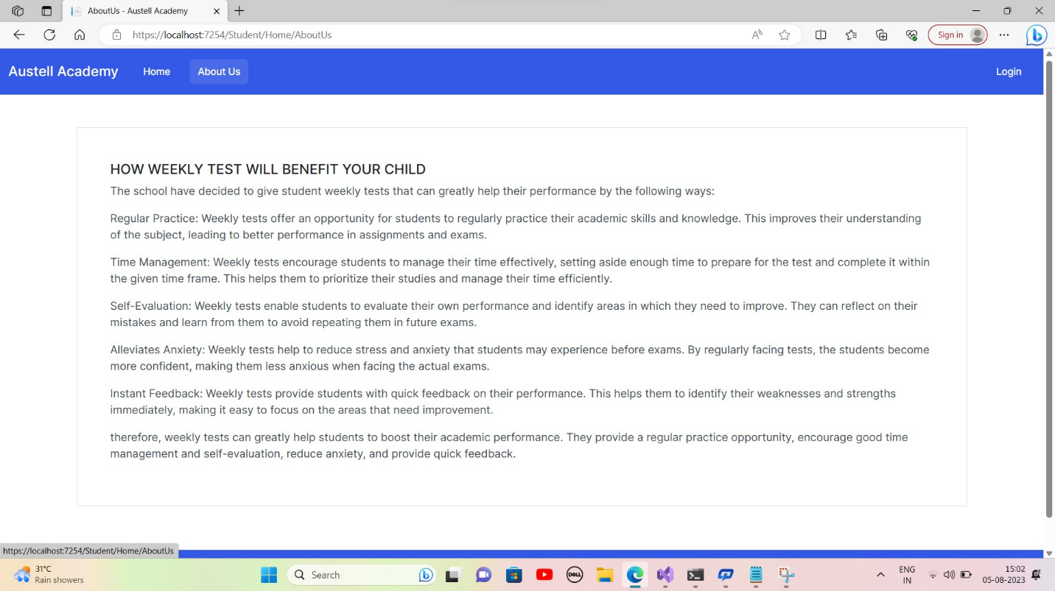**6.3. Login Interface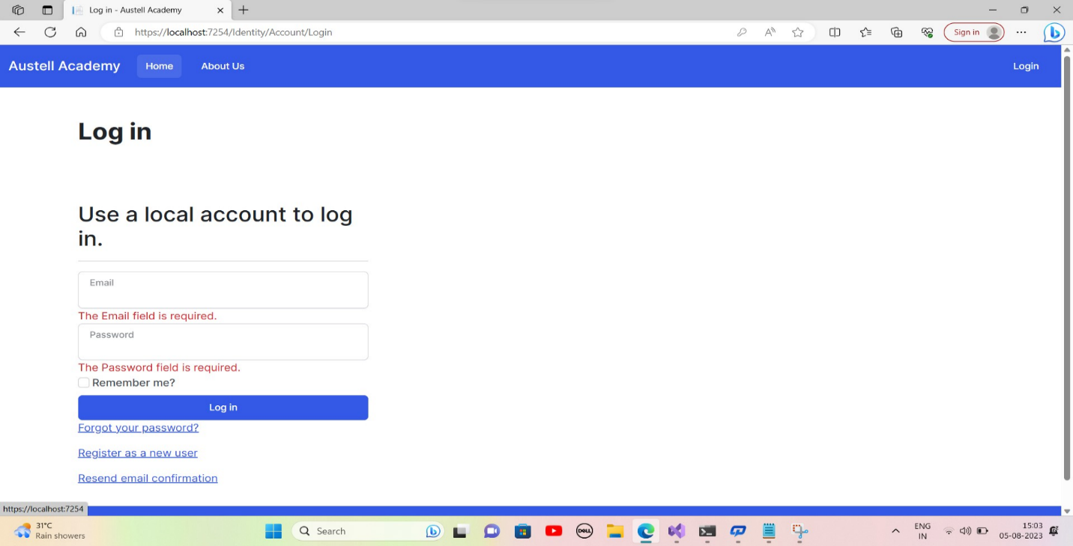6.4. Admin Login Interface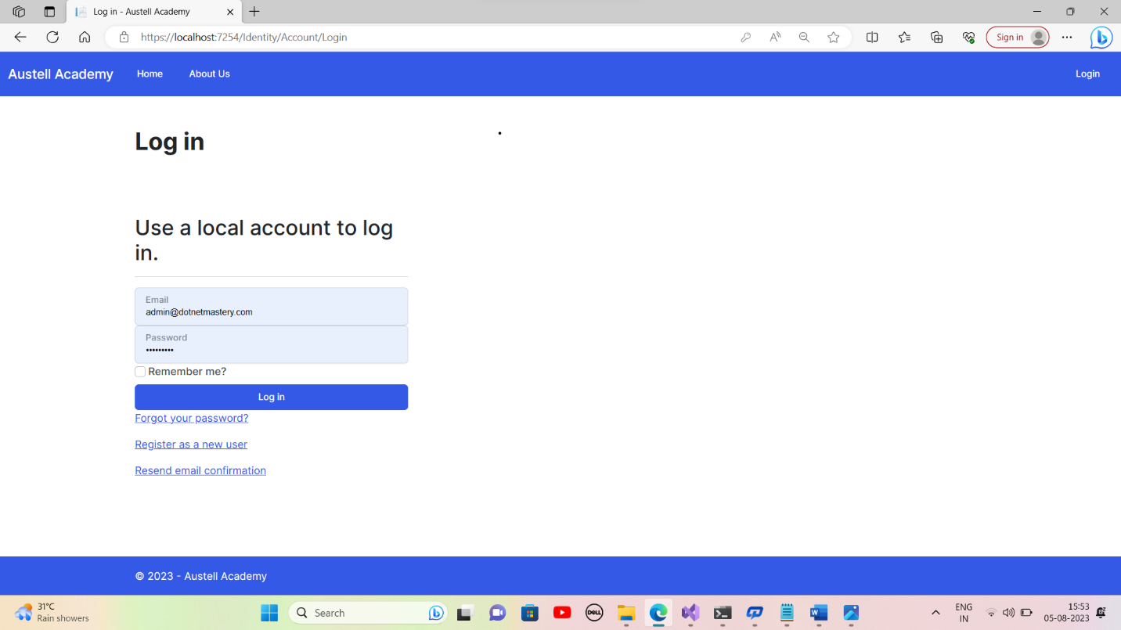6.4.1. Admin Home Page**

### **6.4.2. Question List**

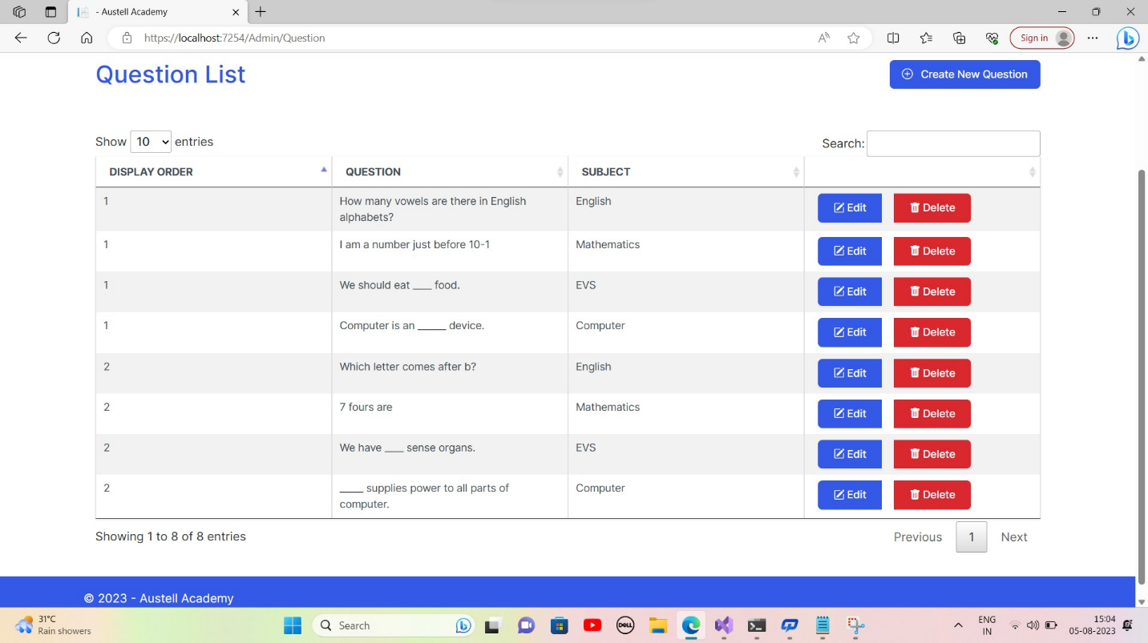 **6.4.3. Create Question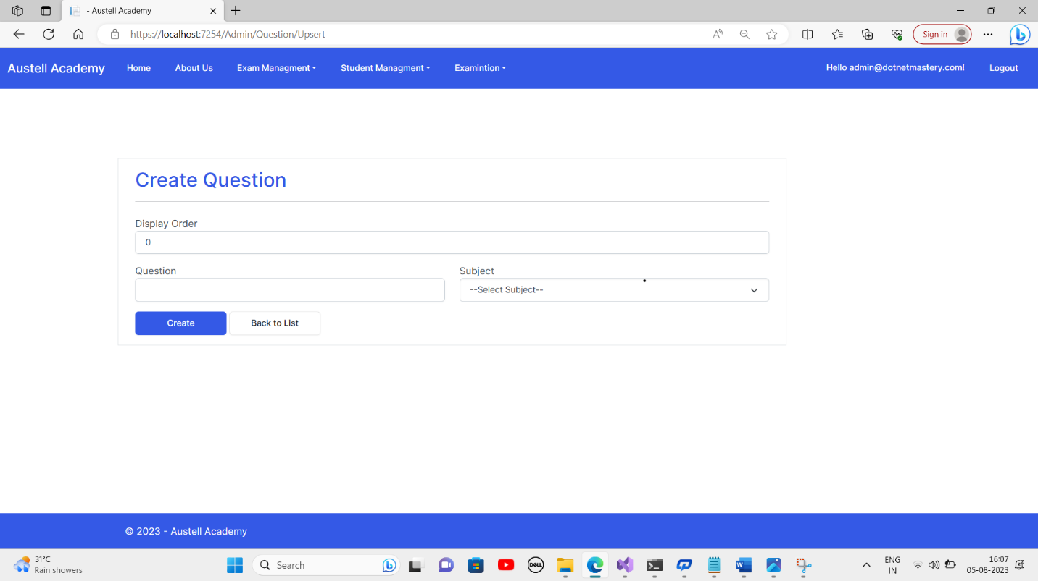6.4.4. Update Question**

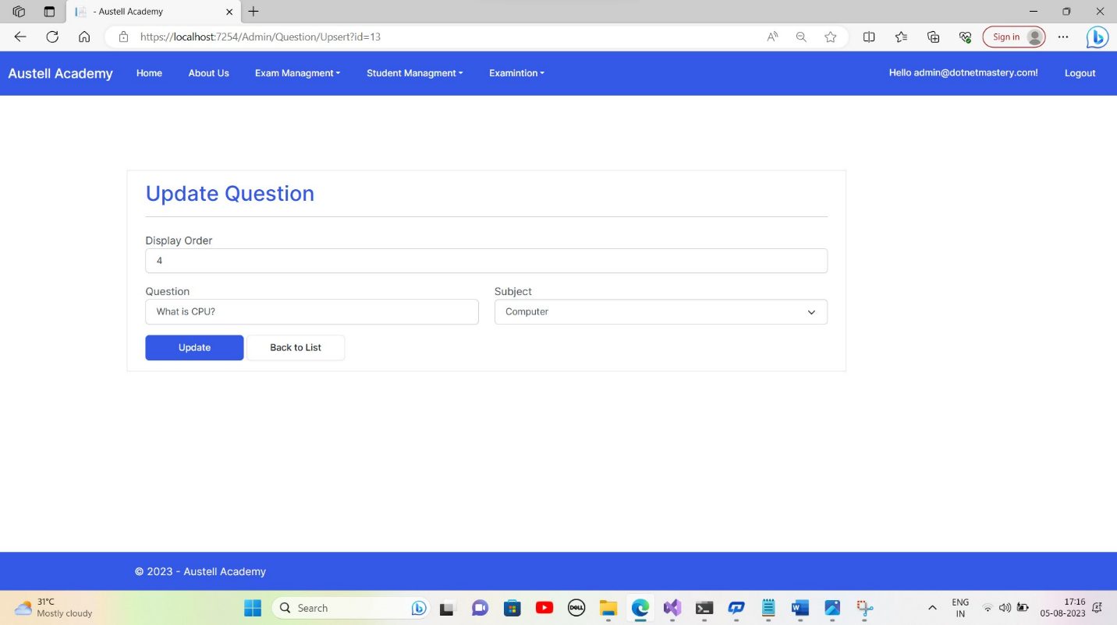**6.4.5. Delete Question**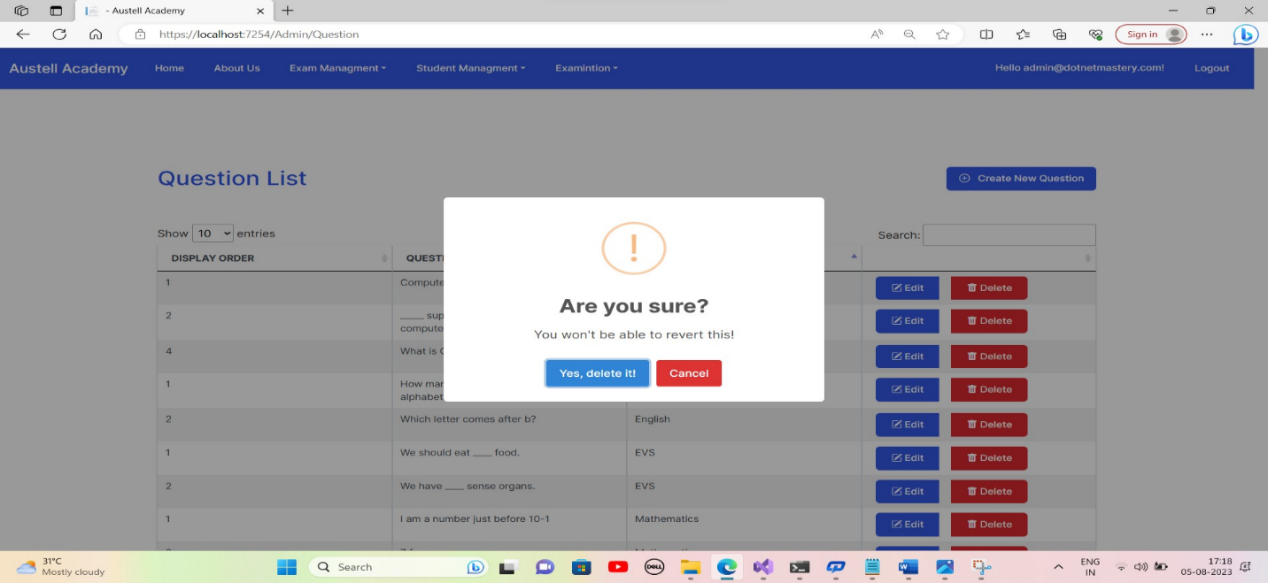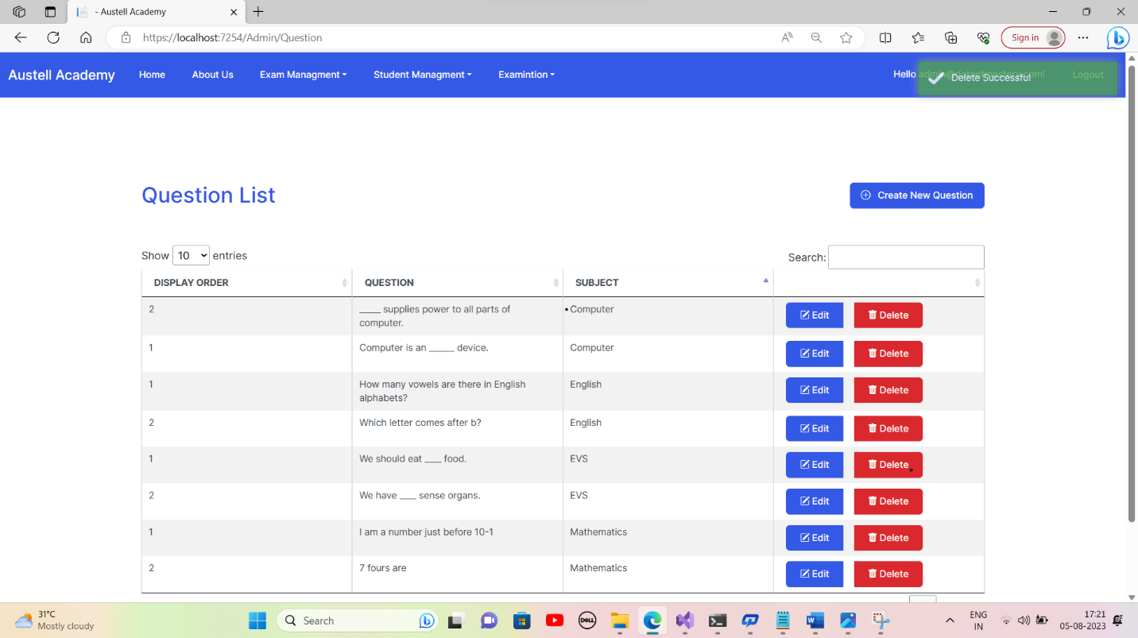

### **6.4.6. Choice List**

### 

### **6.4.7. Create Choice**

### 

### **6.4.8. Update Choice**

### 

**6.4.9 Delete Choice**

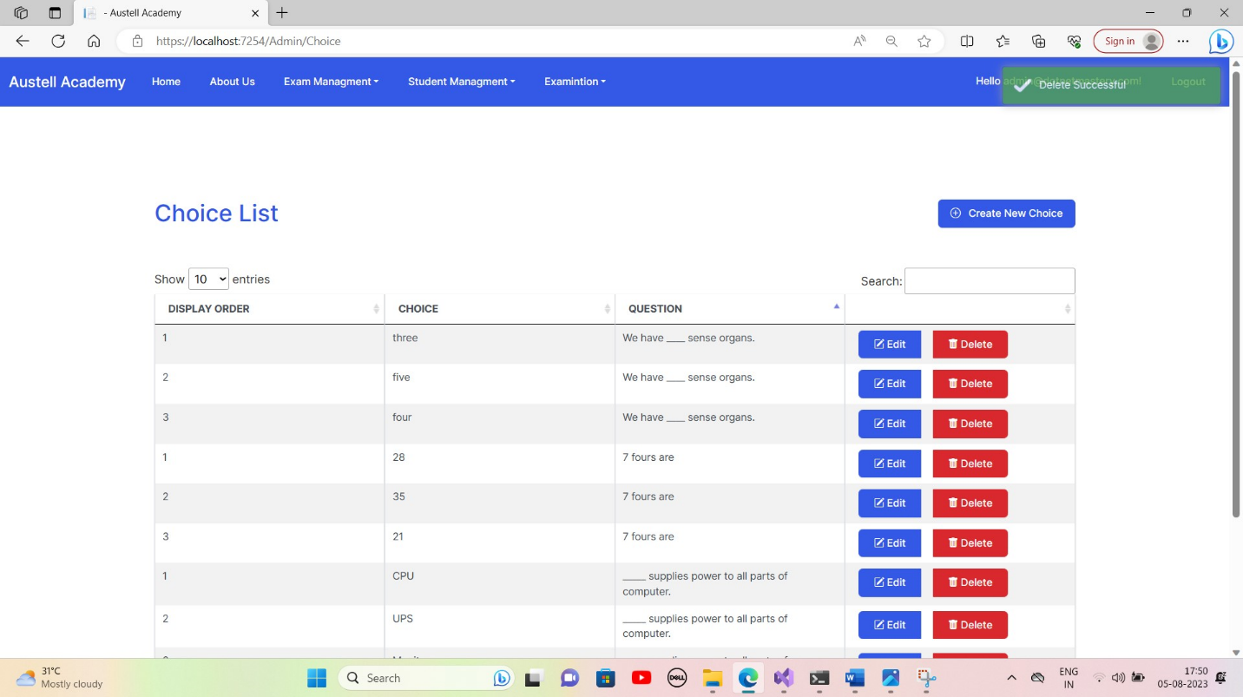

### **6.4.10. Answer List**

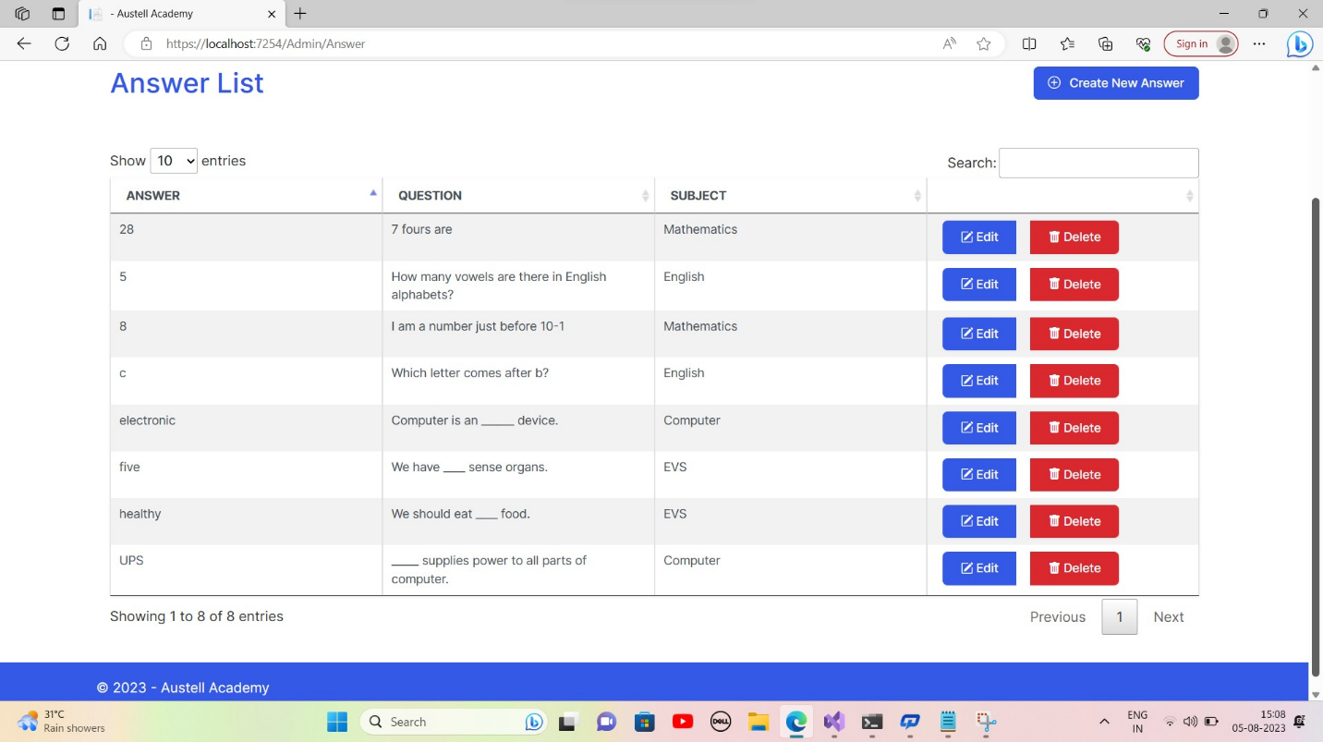**6.4.11. Create Answer**

### 

### **Update Answer**

### **Delete Answer** **6.4.12.Student Subject List**

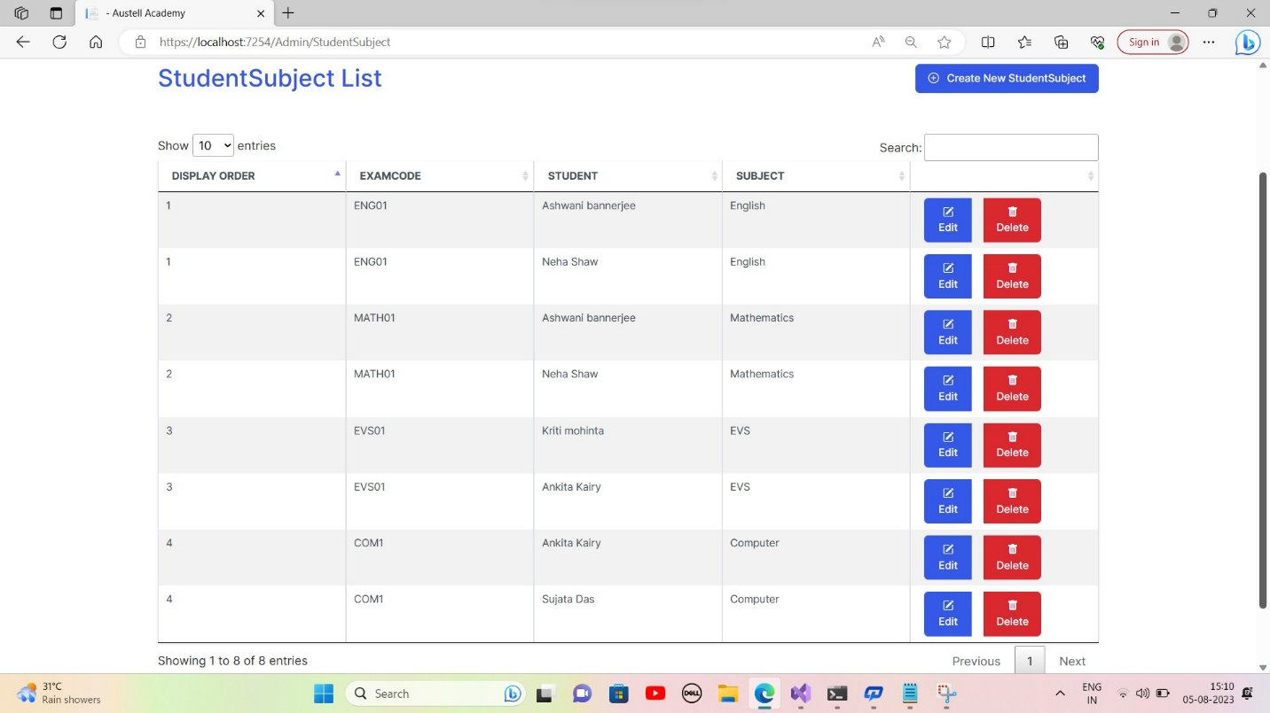

### **6.4.13. Selecting Individual Student for Examination**

**6.4.14. Update Student Subject 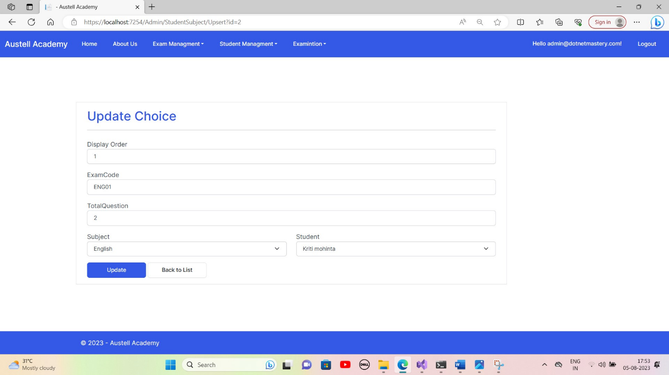6.4.15.Delete Student Subject**

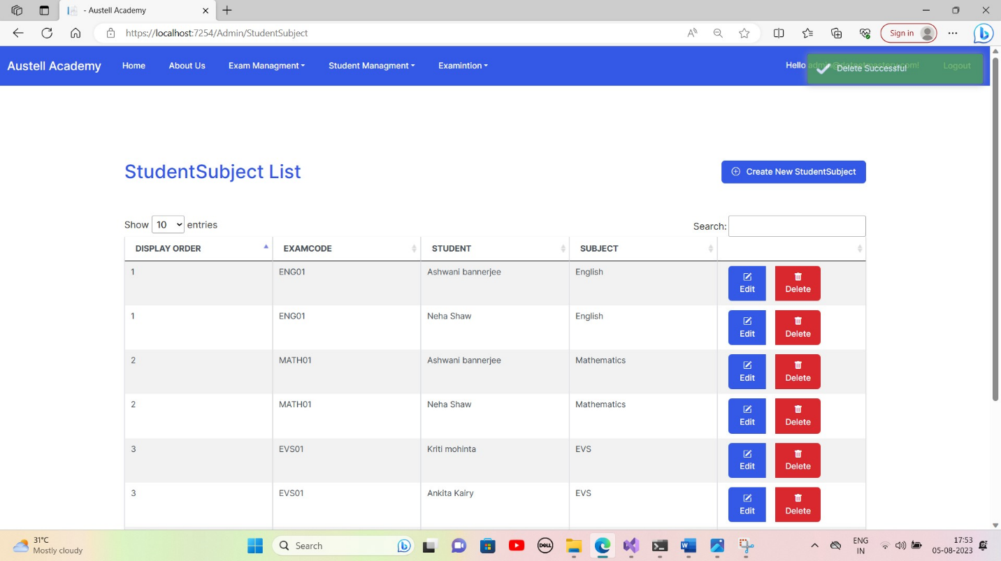**6.4.16. Register in Admin Portal**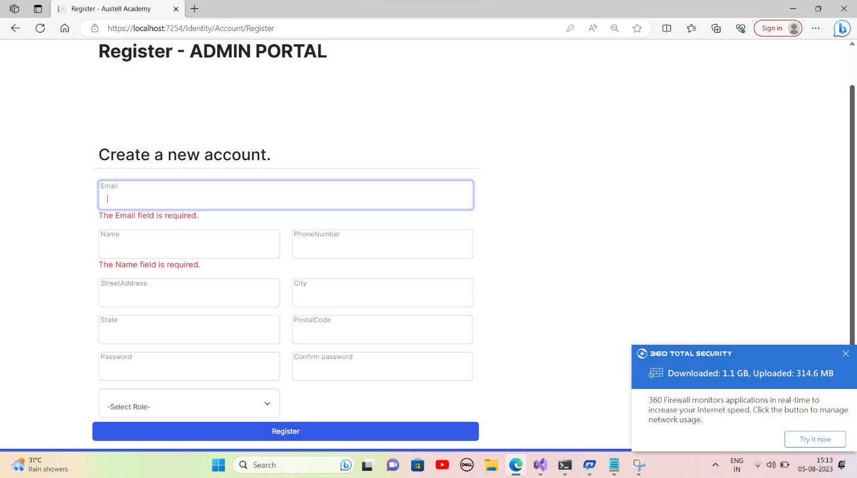

### **6.4.17. Subject List**

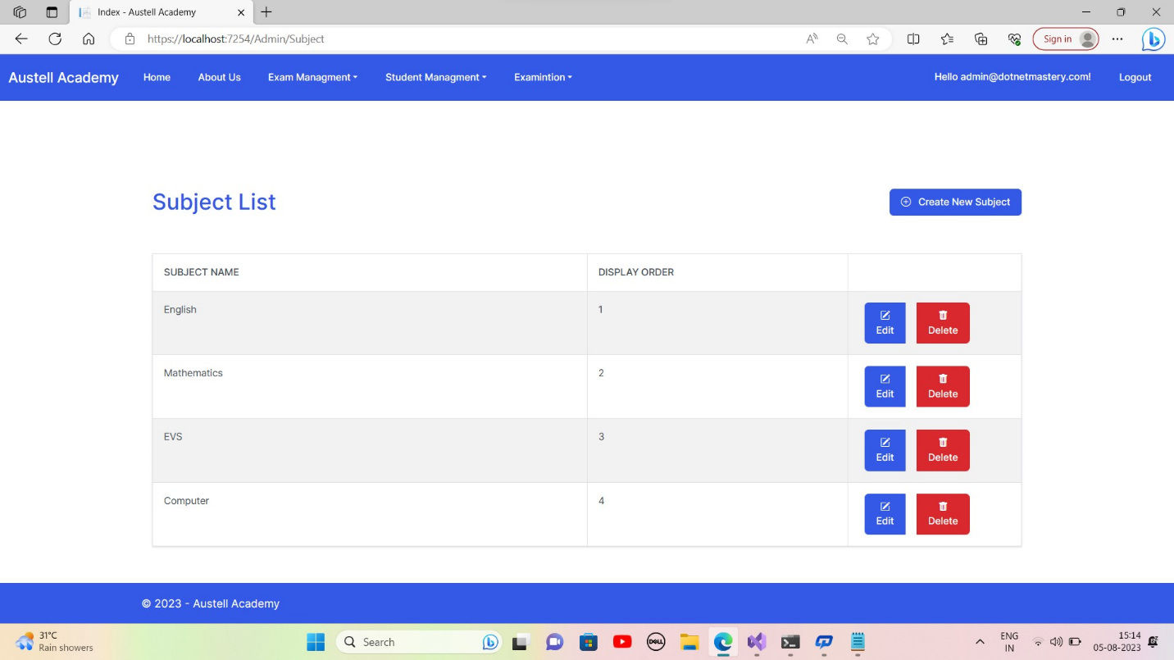**6.4.18. Create Subject** 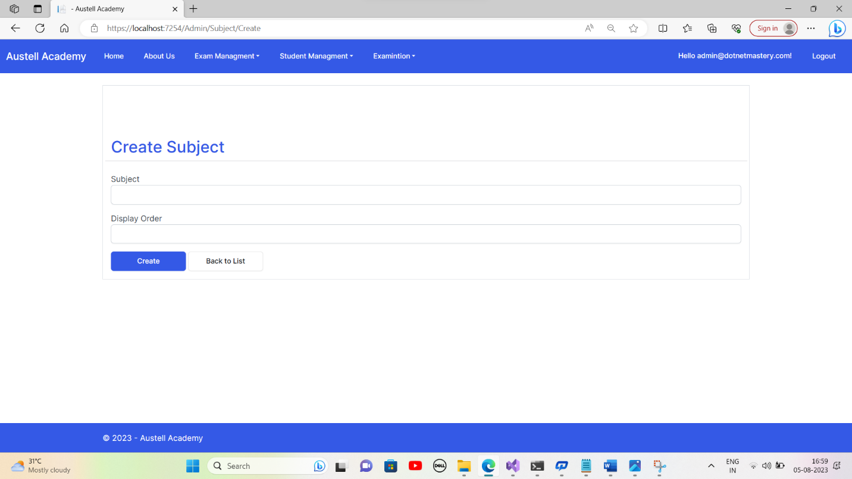

**6.4.19.Update Subject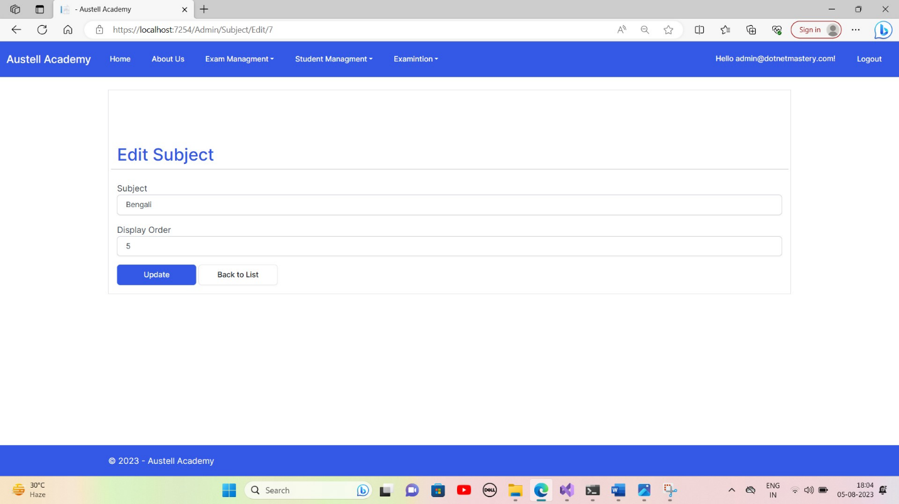6.4.20.Delete Subject**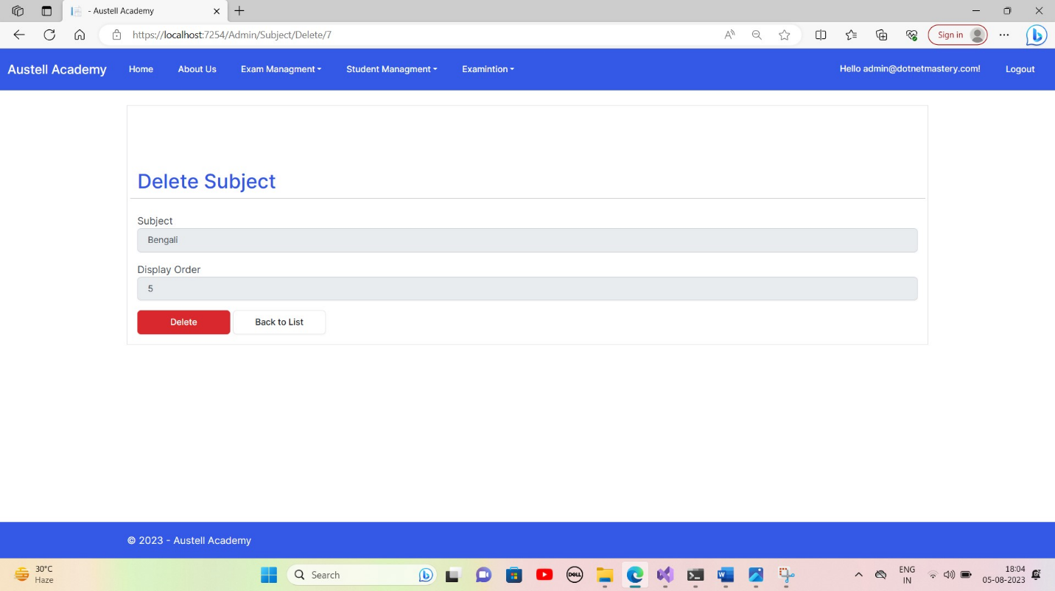

### 

### **6.4.21. Class List**

### **6.4.22. Create Class**

### 

**6.4.23. Edit Class 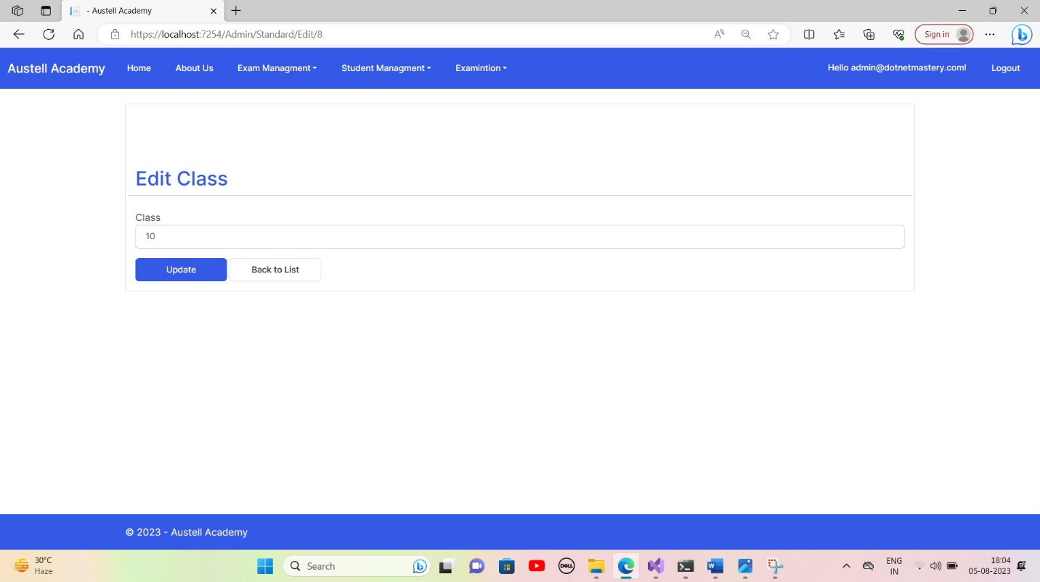6.4.24. Delete Class** 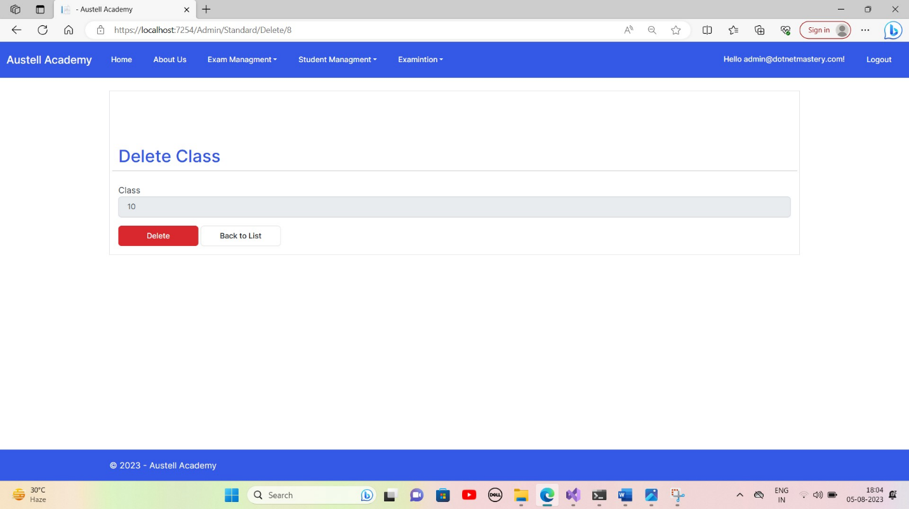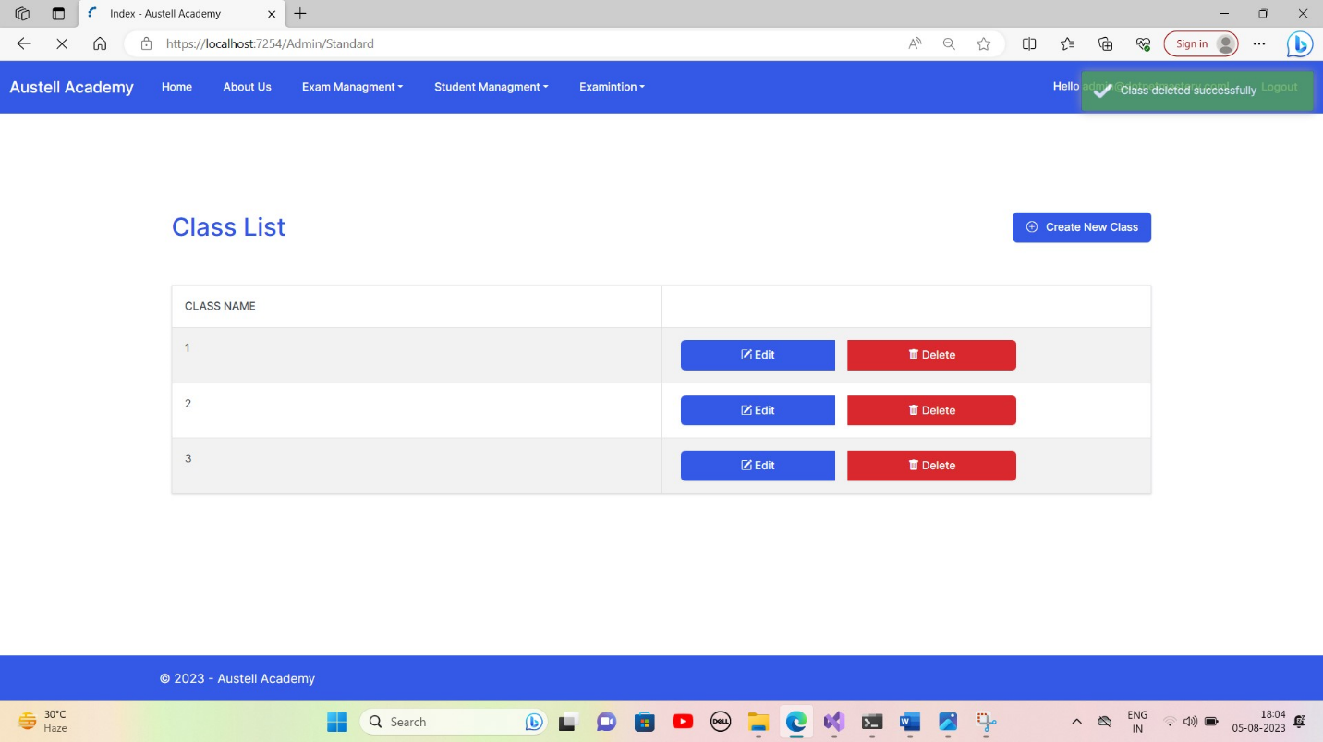

### **6.4.25. Student List**

### **6.4.26. Create Student**

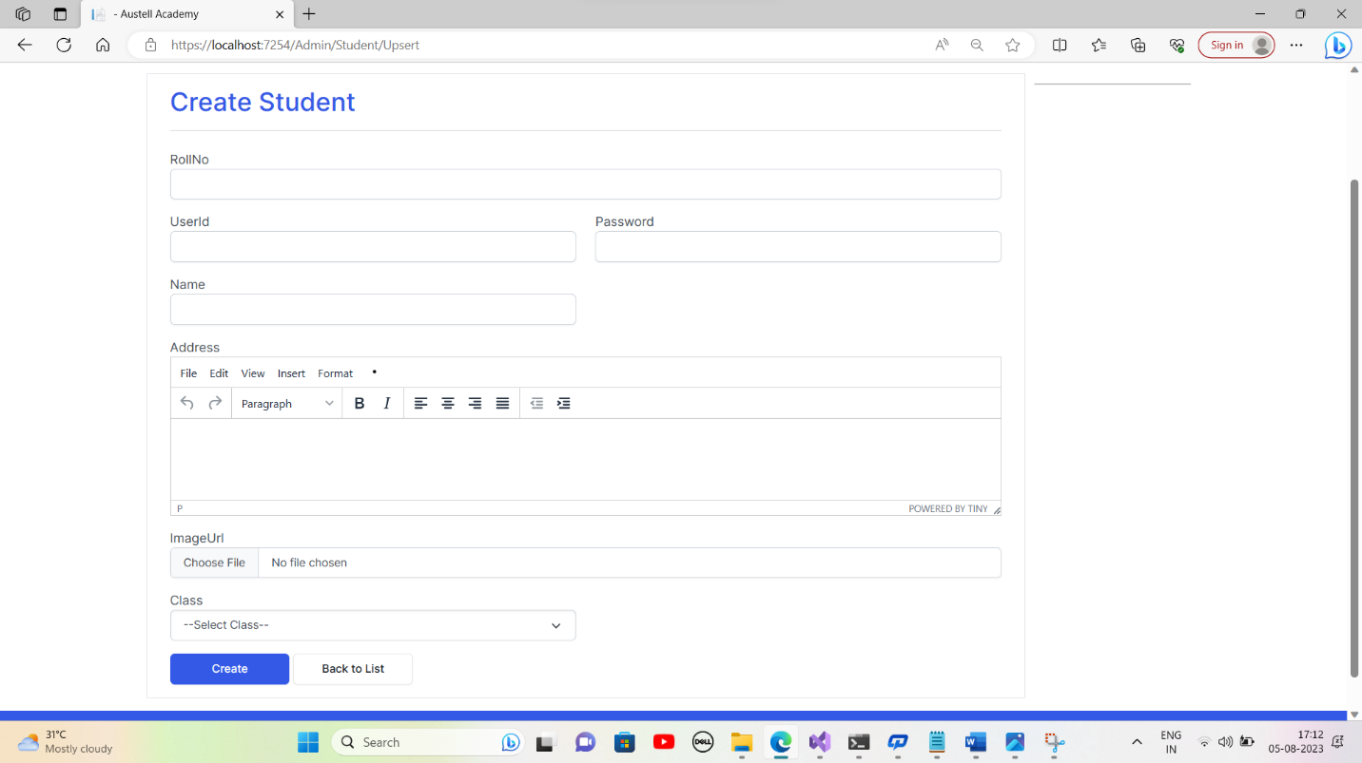**6.4.27. Update Student 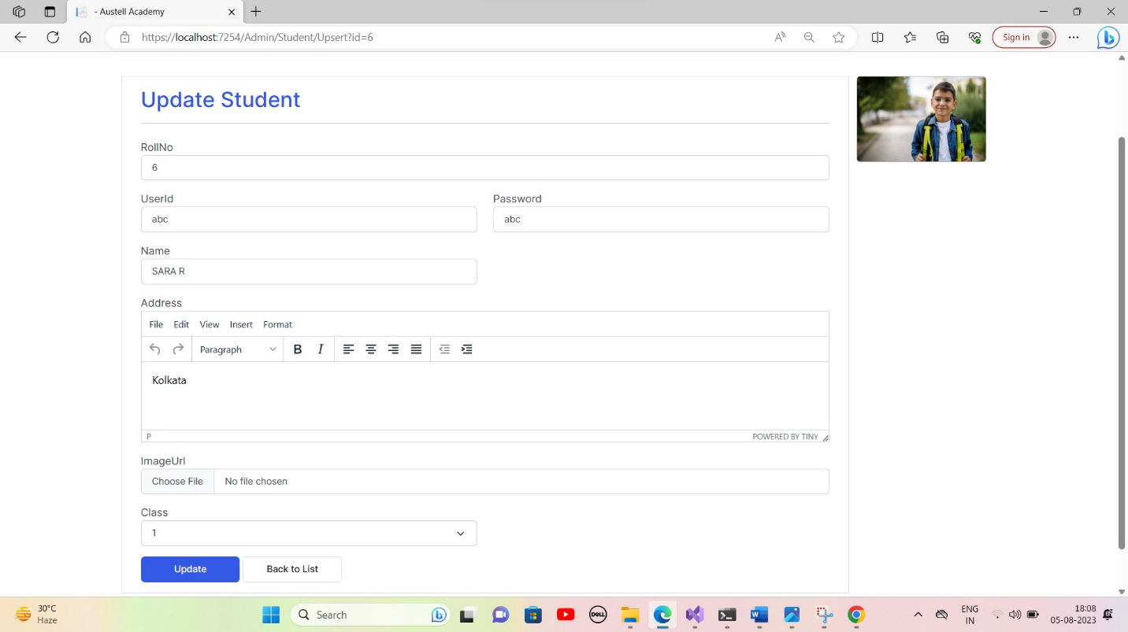6.4.28. Delete Student** 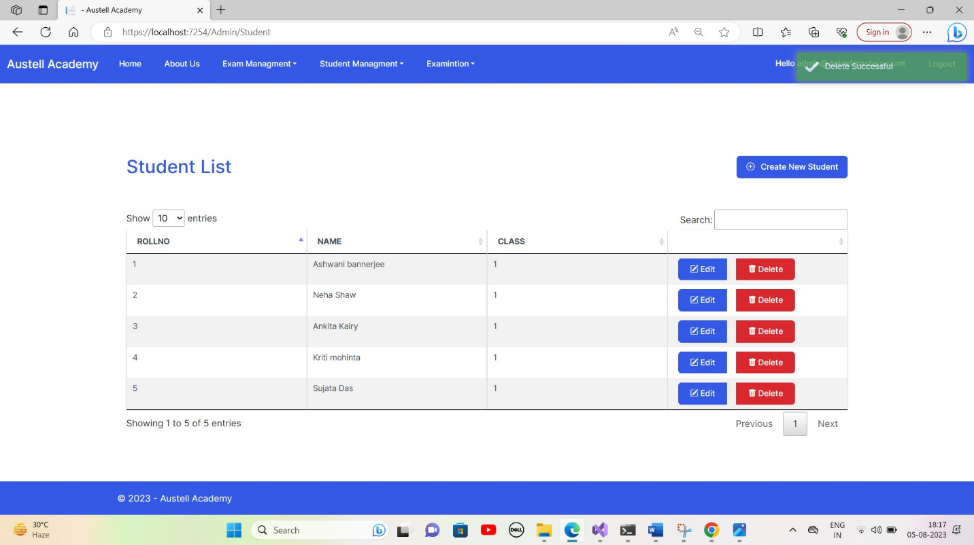

### **6.4.29. Create Student Examination Portal**

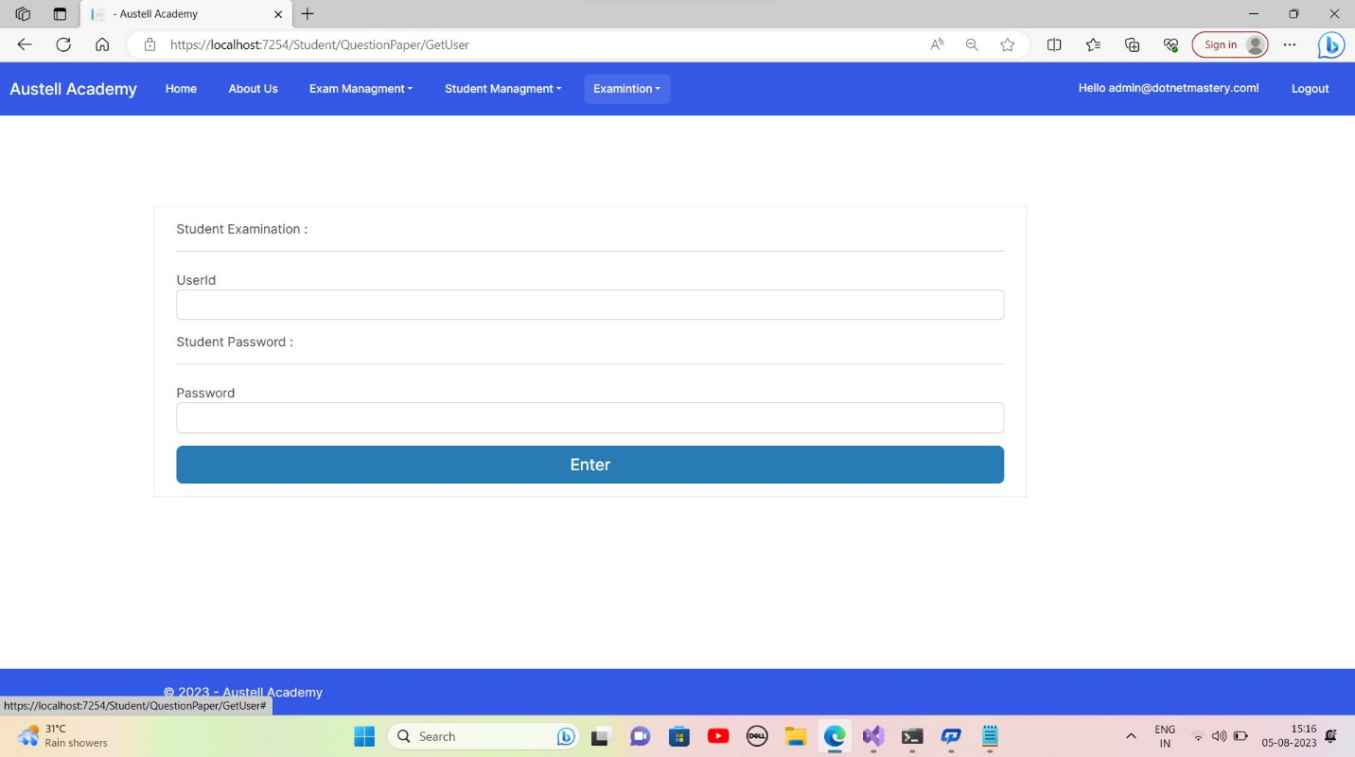**6.4.30. Student Login Interface**

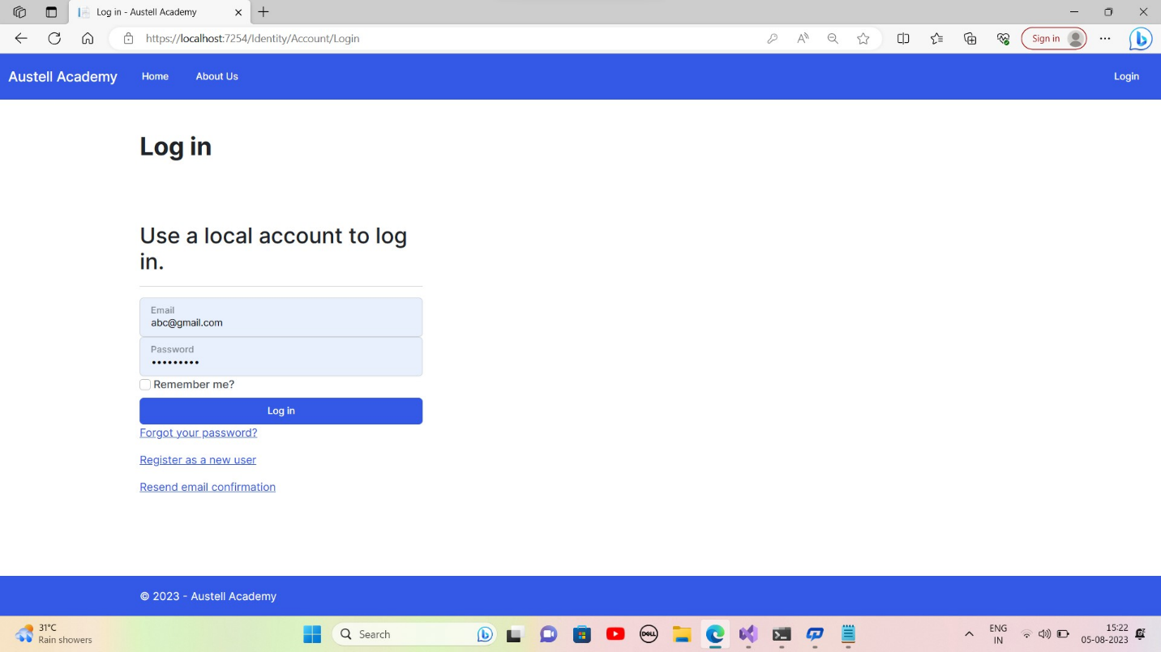**6.4.31. Student Home Page**

### **6.4.32. Student Examination Login Interface**

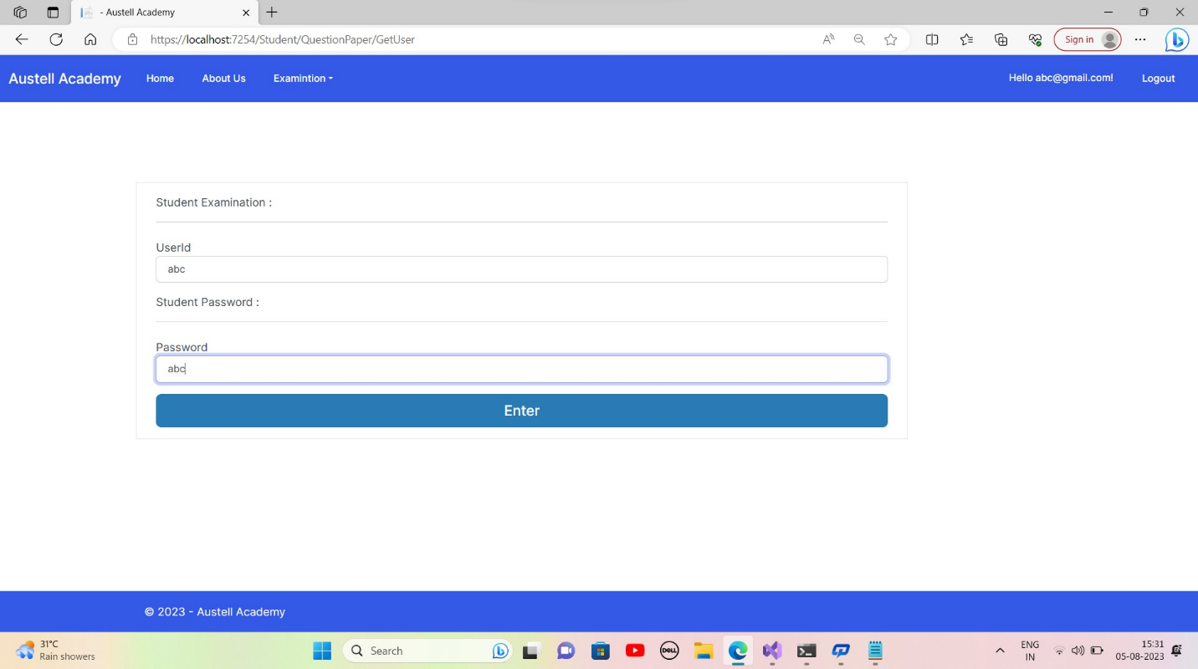

### **6.4.33. Student Examination List**

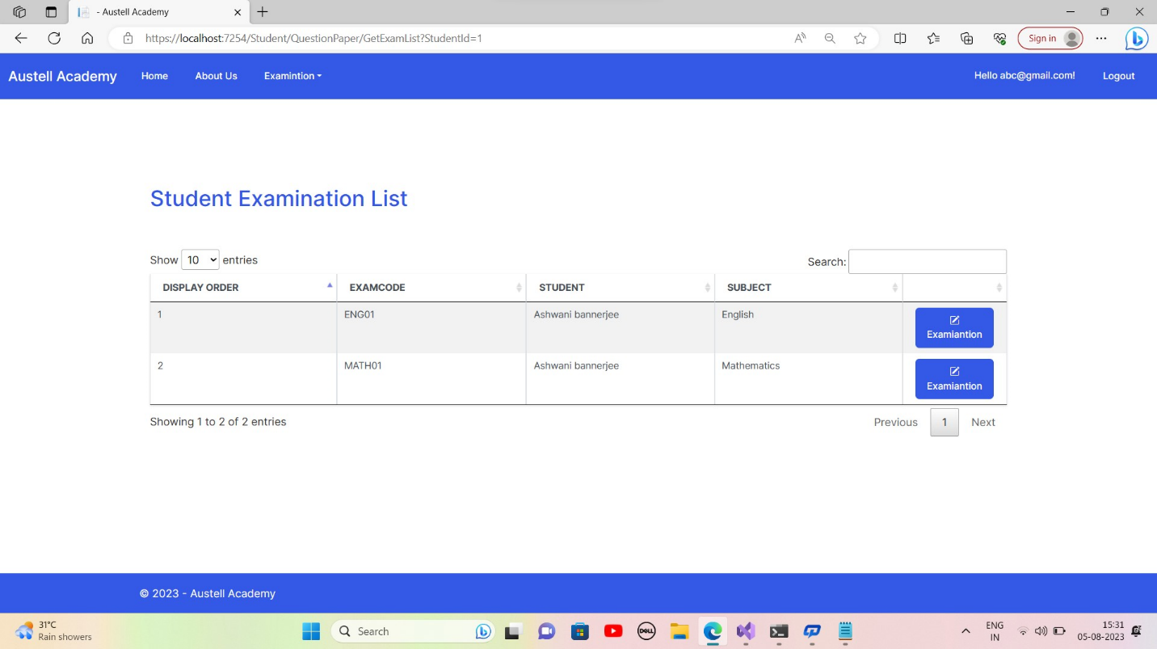

**6.4.34. Attemping Exam 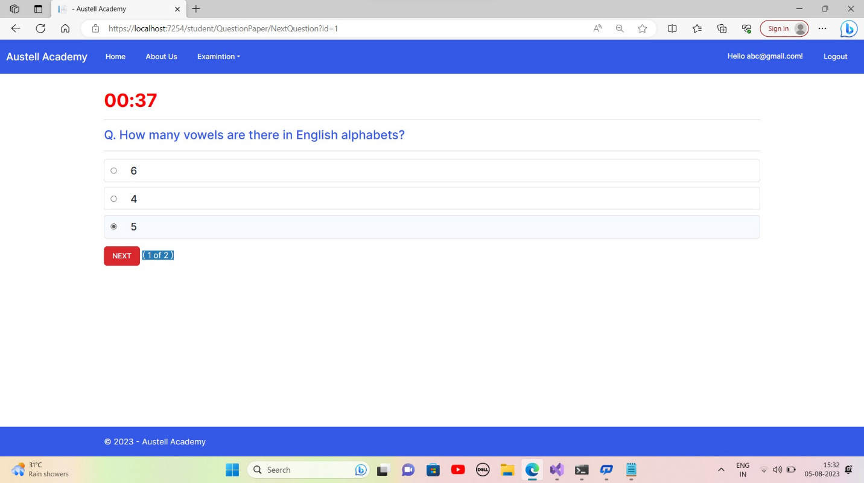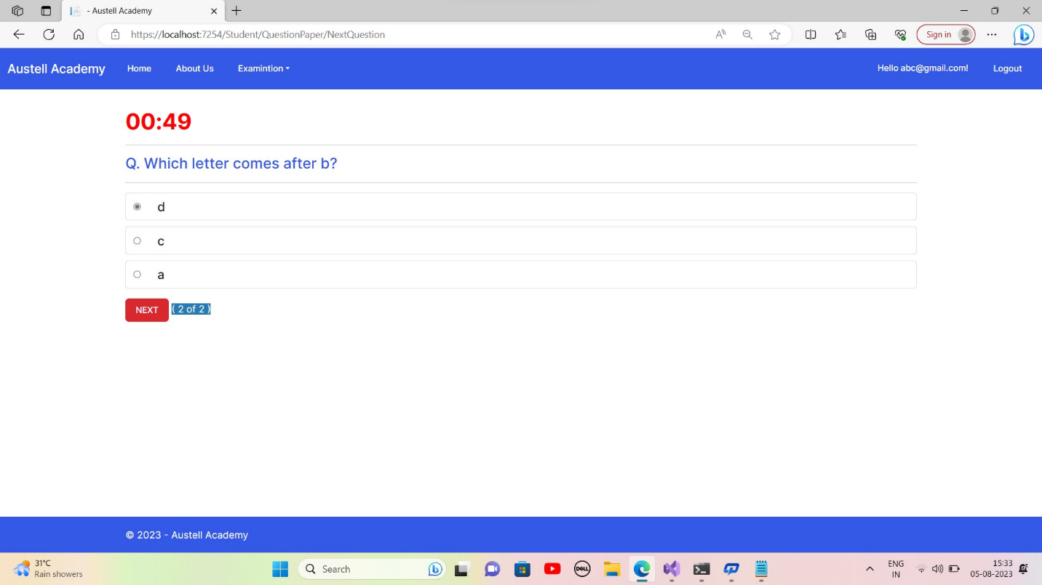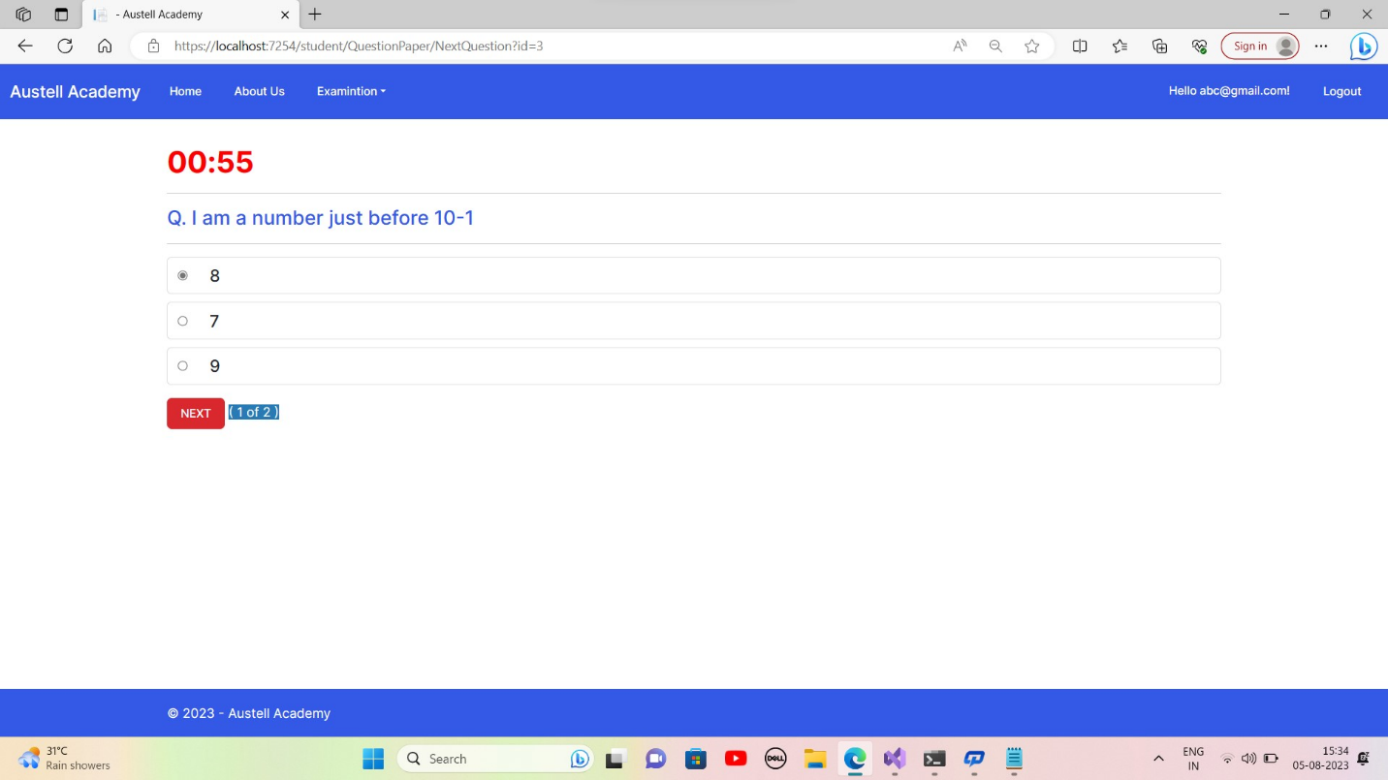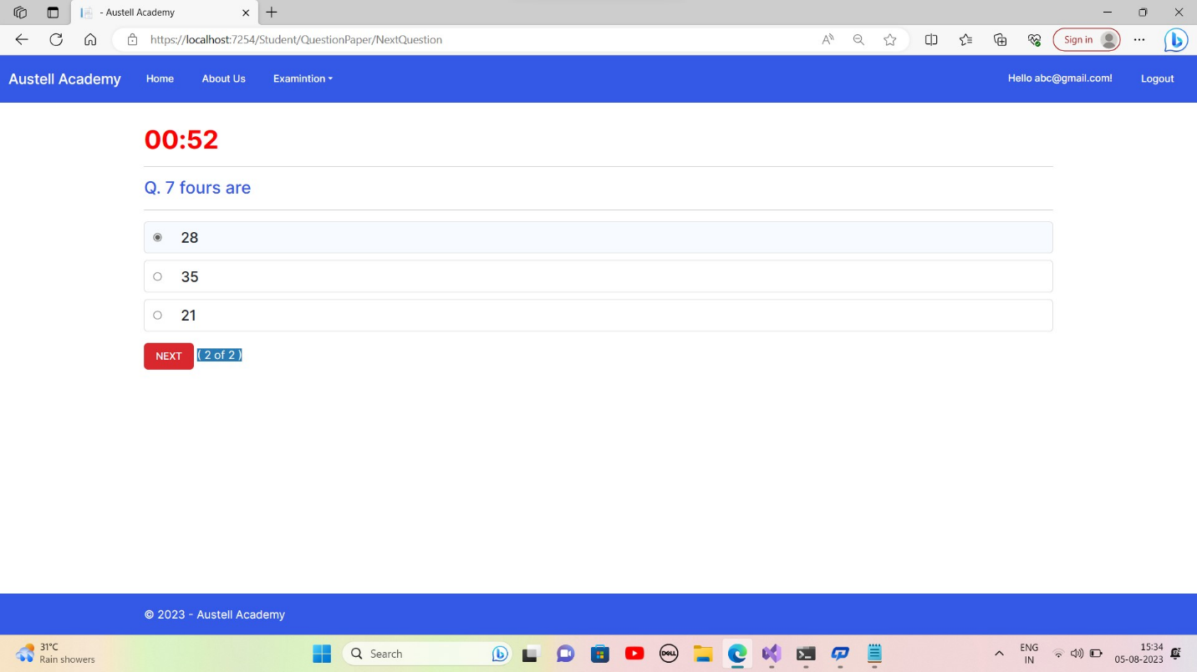6.4.35. Student Performance**

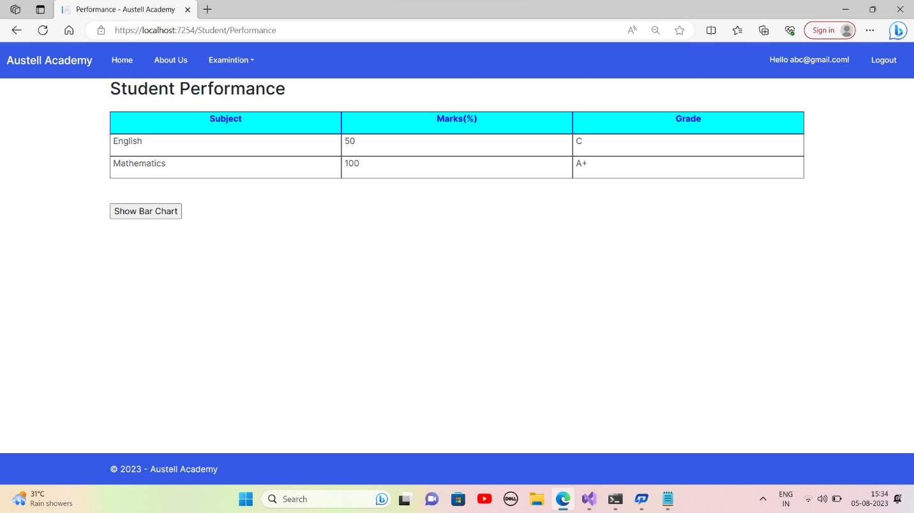

7.Test case For Log In:

Project : - Online Examination System.

Objective : - To check whether user name & Password valid or invalid.

Page : - Login Screen.

Test Data : - User=”admin@dotnetmastery.com” and Password =”Admin123*”.

|  |  |  |  |  |  |
| --- | --- | --- | --- | --- | --- |
| *Sr*  *No*  *.* | Steps | Data | Excepted Data | Actual result | Status |
| *1* | Enter user name, password and press submit button |  | Should navigate to admin’s page |  | Pass |
| *2* | Enter User name and press submit button. |  | Should Display message box ‘please  fill all the fields’ |  | Pass |
| *3* | Enter password and press submit button |  | Should Display message box ‘please  fill all the fields’ |  | Pass |
| *4* | Enter blank user name and blank password and press submit button. |  | Should display a message box ‘please  fill all the fields’ |  | Pass |
| *5* | Enter wrong user and password. |  | Should display a message box ‘Invalid  ID or Password’ |  | Pass |

Test case For Navigation:

Project : - Online Examination System.

Objective : - To check whether different hyperlinks are working properly or not. Prepared By: - Team-P

Page : - home page (default page).

|  |  |  |  |  |  |
| --- | --- | --- | --- | --- | --- |
| *Sr No.* | Steps | Data | Excepted Data | Actual Result | Status |
| 1 | Click on Home page hyperlink menu |  | Should display home page |  | Pass |
| 2 | Click on question hyperlink menu |  | Should display questionnaires details  page |  | Pass |
| 3 | Click on Examination hyperlink menu |  | Should display exam  details page |  | Pass |
| 4 | Click on show result hyperlink menu |  | Should display result details page |  | Pass |
| 5 | Click on login hyperlink menu |  | Should display  respective login page |  | Pass |
| 6 | Click on queries  grid |  | Should display queries details |  | Pass |
| 7 | Click on exampaper hyperlink menu |  | Should display exampaper page |  | pass |

**8.** **Source code**

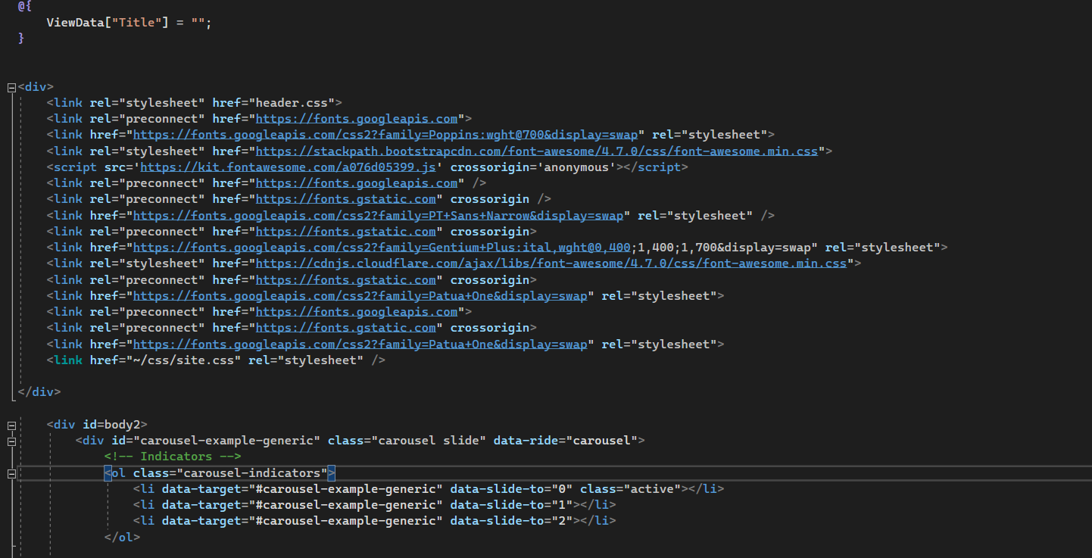

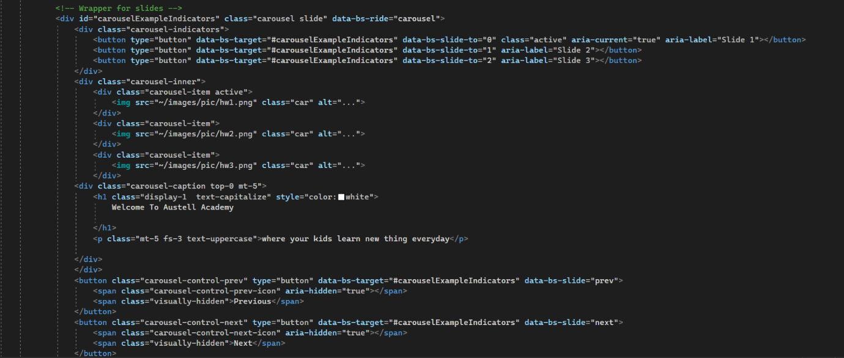

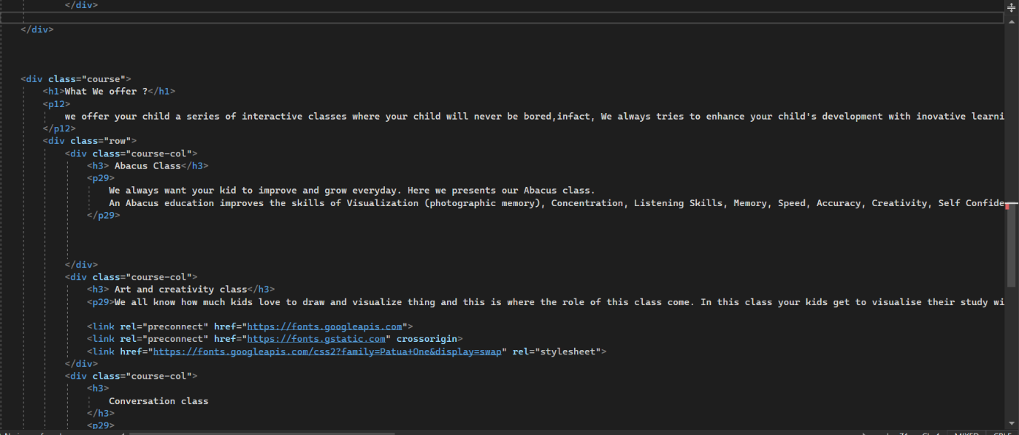

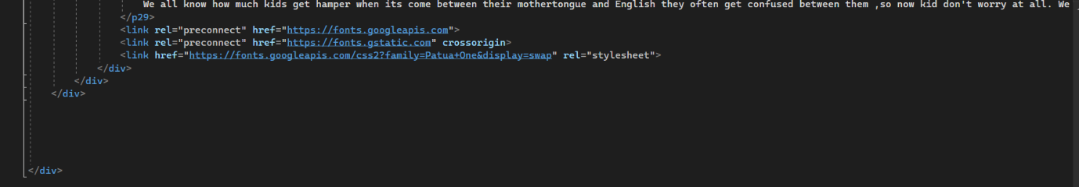

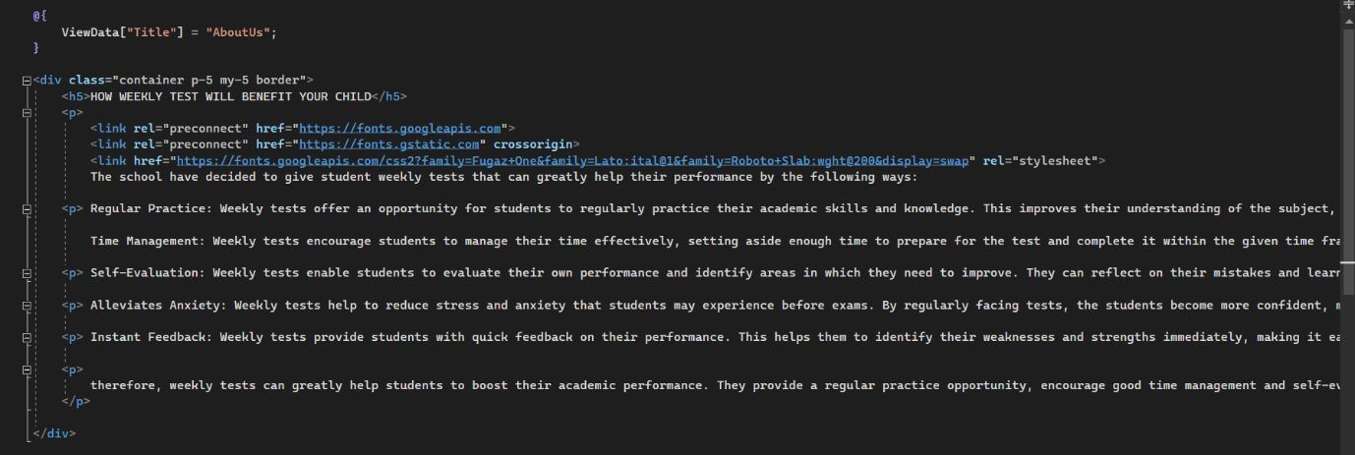

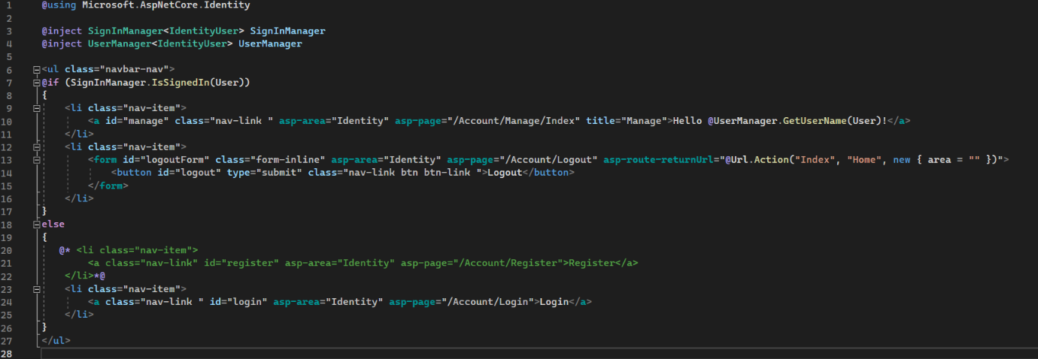

**9. Scope for Enhancement**

Present system carries certain drawbacks and limitations as listed below

1. Current system provides only multiple choices but single correct answer selection.
2. Incase questions and/or answers need to be in graphics, current system has no provision.
3. Unregistered users cannot answer test, they must belong to some exam code . This is a drawback in case the admin wants anyone even anonymous users to answer the test.
4. Security logs though not implemented in this system would be well available through the respective database management system and web server software.

5.If any one wants to know the details about the student this will be further enhanced.